**IMAGE GENERATION USING STYLE TRANSFER**

**A PROJECT REPORT**

*Submitted in partial fulfillment of the requirements for the award of the degree of*

**BACHELOR OF TECHNOLOGY**

***in***

**INFORMATION TECHNOLOGY**

### By

**GANTA GNANESH (20JR1A1261) BODUU VENKATA YASHWANTH (20JR1A1242) IMMADISETTI ABHINESH (20JR1A1266)**

**GAJVALLI JAYA SRIRAM (20JR1A1259)**

Under the Guidance of **Mrs. B. Nagaeswari M.Tech** Assistant Professor, Dept. of IT



**DEPARTMENT OF INFORMATION TECHNOLOGY**

**KKR & KSR INSTITUTE OF TECHNOLOGY AND SCIENCES**

**(Autonomous)**

Vinjanampadu (V), Vatticherukuru(M), Guntur -522017

**JAWAHARLAL NEHRU TECHNOLOGICAL UNIVERSITY KAKINADA:: KAKINADA**

APRIL-2024

**CERTIFICATE**

This is to certify that this project report entitled “**IMAGE GENERATION USING STYLE TRANSFER”** submitted by **G.Gnanesh (20JR1A1261), B.Venkata Yashwanth (20JR1A1242), I.Abhinesh (20JR1A1266), G.Jaya SriRam (20JR1A1259)** to Jawaharlal Nehru Technological University Kakinada, through KKR & KSR Institute of Technology and Sciences (Autonomous) for the award of the Degree of Bachelor of Technology in **INFORMATION TECHNOLOGY** is a bonafide record of project work carried out by them under my supervision during the year 2023-24.

B. NAGAESWARI Dr. M. SRINIVASA SESHA SAI

**SUPERVISOR HEAD OF THE DEPARTMENT**

M.TECH

**INTERNAL EXAMINER EXTERNAL EXAMINER**

**DECLARATION**

We here by declare that the project **“IMAGE GENERATION USING STYLE TRANSFER”** has been carried out by us and this work has been submitted to KKR & KSR Institute of Technology and Sciences (A), Vinjanampadu, affiliated to Jawaharlal Nehru Technological University, Kakinada in partial fulfillment of the requirements for the award of degree of Bachelor of Technology in Information Technology.

We further declare that this project work has not been submitted in full or part for the award of any other degree in any other educational institutions.

1. **20JR1A1261 Ganta Gnanesh**
2. **20JR1A1242 Boddu Venkata Yashwanth**
3. **20JR1A1266 Immadisetti Abhinesh**
4. **20JR1A1259 Gajvalli Jaya Sriram**

**ACKNOWLEDGEMENT**

We would like to express our profound gratitude towards **B. Nagaeswari**, Department of Information Technology**,** who played a supervisory role to utmost perfection, enabled us to seek through our IV-II B. Tech project and for guidance as an internal guide methodically and meticulously.

We express our gratitude towards all the faculty members and non-teaching faculty members, Department of INFORMATION TECHNOLOGY.

We are highly indebted to **Prof. M. Srinivasa Sesha Sai**, **Head of the Department, Information Technology** for providing us with all the necessary support.

We render our deep sense of gratitude to **Dr. P. BABU, Principal and Dr.**

**K. Hari Babu, Director Academics** for permitting us to carry out our main project works. We would like to express our sincere thanks to Information Technology staff for lending us their time to help us complete the work successfully.

We are very much thankful to the **Sri K. Subba Rao, Chairman and**

**Sir K. Sekhar Secretary** for their continuous support and the facilities provided. We would also like to thank our staff, parents, and friends for their enduring encouragement and assistance **whenever** required.

**INSTITUTE VISION AND MISSION**

**INSTITUTION VISION**

* To produce eminent and ethical Engineers and Managers for society by imparting quality professional education with an emphasis on human values and holistic excellence.

**INSTITUTION MISSION**

* To incorporate benchmarked teaching and learning pedagogies in the curriculum.
* To ensure the all-around development of students through a judicious blend of curricular, co-curricular, and extra-curricular activities.
* To support the cross-cultural exchange of knowledge between industry and academy.
* To provide higher/continued education and research opportunities to the employees of the institution.

**DEPARTMENT OF INFORMATION TECHNOLGOY**

**VISION OF THE DEPARTMENT**

* To produce competant professionals in the field of Information Technology to meet the global needs of industry and society.

**MISSION OF THE DEPARTMENT**

|  |  |
| --- | --- |
| **DM1** | Strengthen the Core Competence through the state-of-the-art concepts in a congenial Environment. |
| **DM2** | Promote innovative research and development for the application of IT to the Economic, Social and Environmental users. |
| **DM3** | Inculcate professional behaviour, lifelong learning and strong ethical values to meet the challenges in Information Technology |
| **DM4** | Establish centers of excellence in leading areas of Information Technology |

|  |
| --- |
| **PROGRAM SPECIFIC OUTCOME (PSO’S)** |
| **PSO1: Application Development**  Able to develop the business solutions through Latest Software Techniques and tools for real time Applications. |
| **PSO2: Professional and Leadership**  Able to practice the profession with ethical leadership as an entrepreneur through participation in various events like Ideathon, Hackathon, project expos and workshops. |
| **PSO3: IT infrastructure**  Ability to Analyze and recommend the appropriate IT infrastructure required for the implementation of a project |

|  |
| --- |
| **Program Educational Objectives (PEOs)** |
| **PEO 1:**  **Domain Knowledge**: Have a strong foundation in areas like mathematics, science and engineering fundamentals so as to enable them to analyse and solve engineering problems and prepare the students to careers, R&D and studies of higher level. |
| **PEO 2:**  **Professional Employment**: Have the ability to analyse and understand the requirements of software, and technical specifications required and provide novel engineering solutions to the problems associated with hardware and software. |
| **PEO 3:**  **Higher Degrees**: Have exposure to cutting edge technologies thereby making them to achieve excellence in the areas of their studies. |
| **PEO 4:**  **Engineering Citizenship**: Work in teams on multi-disciplinary projects with effective communication skills and leadership qualities. |
| **PEO 5:**  **Lifelong Learning**: Have a successful career wherein they strike a balance between ethical values and commercial values. |

**PROGRAM OUTCOMES (POS)**

1. **Engineering knowledge:**

Apply the knowledge of mathematics, science, engineering fundamentals, and an engineering specialization to the solution of complex engineering problems.

1. **Problem analysis:**

Identify, formulate, research literature, and analyze complex engineering problems reaching substantiated conclusions using the first principles of mathematics, natural sciences, and engineering sciences.

1. **Design/development of solutions:**

Design solutions for complex engineering problems and design system components or processes that meet the specified needs with appropriate consideration for public health and safety, and cultural, societal, and environmental considerations.

1. **Conduct investigations of complex problems:**

Use research-based knowledge and research methods including design of experiments, analysis and interpretation of data, and synthesis of the information to provide valid conclusions.

1. **Modern tool usage:**

Create, select, and apply appropriate techniques, resources, and modern engineering and IT tools including prediction and modeling to complex engineering activities with an understanding of the limitations.

1. **The engineer and society:**

Apply reasoning informed by the contextual knowledge to assess societal, health, safety, legal and cultural issues and the consequent responsibilities relevant to the professional engineering practice.

1. **Environment and sustainability:**

Understand the impact of professional engineering solutions in societal and environmental contexts, and demonstrate the knowledge of, and need for sustainable development.

1. **Ethics:**

Apply ethical principles and commit to professional ethics and responsibilities and norms of the engineering practice.

1. **Individual and team work**:

Function effectively as an individual, and as a member or leader in diverse teams, and in multidisciplinary settings.

1. **Communication**:

Communicate effectively on complex engineering activities with the engineering community and with society at large, such as being able to comprehend and write effective reports and design documentation, make effective presentations, and give and receive clear instructions.

1. **Project management and finance**:

Demonstrate knowledge and understanding of the engineering and management principles and apply these to one’s own work, as a member and leader in a team, to manage projects and in multidisciplinary environments.

1. **Life-long learning**:

Recognize the need for, and have the preparation and ability to engage in independent and life-long learning in the broadest context of technological change.

**Course Outcomes (COs)**

**CO421.1:** Perform system of examinations to identify problem.

**CO421.2:** Review the literature/Related work.

**CO421.3:** Defining the problem & it's area of domain.

**CO421.4:** Proposal of solution for the selected area/methodology.

**CO421.5:** Analysis of the proposed work & documentation.

**CO421.6:** Acquire collaborative learning, leadership qualities & presentation skills

**Course Outcomes - Program Outcomes mapping**

|  |  |  |  |  |  |  |  |  |  |  |  |  |  |  |  |
| --- | --- | --- | --- | --- | --- | --- | --- | --- | --- | --- | --- | --- | --- | --- | --- |
|  | **1** | **2** | **3** | **4** | **5** | **6** | **7** | **8** | **9** | **10** | **11** | **12** | **PSO1** | **PSO 2** | **PSO 3** |
| **CO421.1** | 2 | 3 |  | 2 |  | 2 |  |  |  |  |  |  | 3 |  |  |
| **CO421.2** |  |  |  | 3 | 2 |  | 2 |  |  |  |  |  | 3 |  | 2 |
| **CO421.3** |  | 3 |  |  |  | 2 |  |  | 3 | 3 |  | 1 | 2 |  | 1 |
| **CO421.4** |  |  | 2 |  | 3 | 2 | 2 | 2 |  |  | 1 | 2 | 3 |  | 2 |
| **CO421.5** |  | 2 |  |  | 2 |  |  |  | 2 | 2 |  |  |  | 2 |  |
| **CO424.6** | 1 |  |  |  |  | 2 |  | 2 | 2 | 2 | 2 |  |  | 3 |  |

**3: High 2: Medium 1: Low**

**Program Educational Objectives – Program Specific Outcomes correlation**

|  |  |  |  |
| --- | --- | --- | --- |
|  | **PSO1** | **PSO2** | **PSO3** |
| **PEO1** | 2 | 1 | 3 |
| **PEO2** |  | 3 | 2 |
| **PEO3** | 1 | 2 | 3 |
| **PEO4** | 3 |  | 2 |
| **PEO5** | 1 | 3 | 2 |

**3: High 2: Medium 1: Low**

**CO-PO Mapping with Reasons**

1. **CO421.1** is mapped with PO1, PO2 and PO4, PO6, PO7 as basic knowledge of Engineering and problem Analysis activities are highly essential to conduct examinations on existing systems which have been using in industries as a part of and to define the problem of proposed system.
2. **CO421.2** is mapped with PO1, PO2, PO4 and PO6, PO9, PO10, PO11 as for identification, gathering analysis and classification of requirements for the proposed system, basic knowledge of engineering and Analysis steps along with complex problem analysis through the efforts of team work in order to meet the specific needs of the customer.
3. **CO421.3** is mapped with PO2, PO5 and PO12 as to conduct the literature review and to examine the relevant systems to understand and identify the merits and demerits of each to enhance and develop the proposed as per the need.
4. **CO421.4** is mapped with PO1, PO2, PO3, PO4, PO5 and PO7, PO8, PO9, PO10 because modularization and design of the project is needed after requirements elicitation. For modularization and design of the project, Basic knowledge of Engineering, Analysis capabilities, Design skills and communication is needed between team members as different modules are designed individually before integration.
5. **CO421.5** is mapped with PO3, PO5, PO7, PO9, PO11 and PO12 as to construct the project latest technologies are needed. The development of project is done individually and in groups with well-defined communication by using the engineering and management principles.
6. **CO421.6** is mapped with PO6, PO10 and PO12 because during and after completion of the project, documentation is needed along with proper methods of presentation through understanding and application of engineering and management principles, which in turn needs well defined communication between the team members with all the ethical values. Even the project development team defines the future enhancements as a part of the project development after identifying the scope of the project.

**CO-PSOs Mapping with Reasons**

1. **CO421.1** is mapped with **PSO1** as examining of existing systems and identification of the problem is a part of Application Development activity and identification of evolutionary changes in latest technologies.
2. **CO421.2** is mapped with **PSO1, PSO2** and **PSO3**as identifying and classifying the requirements is a part of Application development and evolutionary computing changes and also follows ethical principles.
3. **CO421.3** is mapped with **PSO1, PSO3** as review of literature is a part of application development activity by recognizing the computing technologies and their evolutionary changes.
4. **CO421.4** is mapped with **PSO1, PSO3** because modularization and logical design is also a part of Application development and follows computing changes using Deep learning technology.
5. **CO421.5** is mapped with **PSO1, PSO2** as Testing, Development and Integration of project activities are part of Application development and follows ethical principles.
6. **CO424.6** is mapped with **PSO2** as for project documentation and presentation; the project team members apply the professional and leadership quality.

**ABSTRACT**

In the world of digital art, Image Style Transfer is a captivating technique that allows artists and enthusiasts to infuse their pictures with the charm of famous artistic styles. This process involves seamlessly applying the visual elements of one image onto another, resulting in a harmonious blend of content and style. This abstract explores the natural and intuitive aspects of Image Style Transfer, shedding light on how enthusiasts can effortlessly transform their photographs into visually striking compositions that resonate with the essence of iconic artistic styles. Join us on a journey where creativity meets simplicity, unlocking the potential for anyone to effortlessly create captivating and naturally stylized images.

The process involves two main components: a content image and a style image. The content image contains the objects and structures we want to preserve, while the style image provides the desired artistic characteristics, such as brushstrokes, textures, and color palettes.

To achieve this, deep convolutional neural networks (CNNs) are typically employed. These networks are pre-trained on large datasets and possess the ability to extract hierarchical features from images. By leveraging the representations learned by these networks, style transfer algorithms can separate and recombine the content and style of two input images.

The core idea behind style transfer is to minimize the content and style differences between the generated image and the content and style reference images, respectively. This is typically achieved by defining appropriate loss functions that quantify these differences. The content loss measures the similarity in content between the generated image and the content reference image, while the style loss captures the differences in style between the generated image and the style reference image.

**Keywords:** Neural Style Transfer (NST), Texture Synthesis, Optimization Methods, Instance Normalization, Convolutional neural networks (CNNs), Loss functions.

**INDEX**

|  |  |
| --- | --- |
| **CHAPTERS ABSTRACT**  **1. INTRODUCTION** | **PAGE NO** |
| 1.1 Introduction of the Project | 1 |
| 1.2 Existing System | 1-2 |
| 1.3 Proposed System | 2-3 |
| 1.4 Potential Users | 3 |
| 1.5 Unique features of the System | 3-4 |
| 1.6 Demand for the product | 4 |
| 1.7 Protection of Idea | 5 |

* 1. **ANALYSIS**
     1. Literature Review 6-9
     2. Requirements Analysis 10
        1. Functional Requirement Analysis 10-12
        2. User Requirements 12
        3. Non-Functional Requirements 12-13
        4. System Requirements 13-14
     3. Modules Description 14-15
     4. Feasibility Study 15
        1. Technical Feasibility 15-16
        2. Operational Feasibility 16
        3. Behavioural Feasibility 16-17
        4. Financial feasibility 17
     5. Process Model Used 18-19
     6. Hardware and Software Requirements 20-21
     7. SRS Specification 21-23
  2. **DESIGN PHASE**
     1. Design Concepts and Constraints 24-46
     2. Design Diagram of the System 46-47
        1. Use Case Diagram 47-48
        2. Sequence Diagram 48-49
     3. Conceptual Design 49-50
     4. Logical Design 50-51
     5. Architectural Design 51-52
     6. Algorithms Design 52-53
     7. Database Design 53-58
     8. Module Design Specifications 59
  3. **CODING INPUT & OUTPUT SCREENS**

|  |  |
| --- | --- |
| 4.1 Sample Coding | 60-71 |
| 4.2 Output Screens | 72-76 |
| 4.3 Screen Reports | 77 |

* 1. **TESTING**
     1. Introduction to testing 78
     2. Types of Testing 78-81
     3. Test Cases and Test Reports 81-87
  2. **IMPLEMENTATION**
     1. Implementation Introduction 88
     2. Implementation Procedure and Steps 88-95
     3. User Manual 96-100
  3. **CONCLUSIONS AND FUTURE ENHANCEMENTS**

|  |  |
| --- | --- |
| 7.1 Conclusions | 101 |
| 7.2 Future Enhancements | 102 |
| 1. **BIBLIOGRAPHY**    1. Books Referred | 103 |
| 8.2 Websites Visited | 103 |
| 8.3 References | 104-106 |

**LIST OF FIGURES**

**FIG NO FIGURE NAME PAGE NO**

1. Process of existing system 2
2. Process of proposed system 3
3. Process of water fall model 19
4. Design Diagram of the System 47
5. Use case Diagram 48
6. Sequence Diagram 49
7. Conceptual Design 50
8. Logical Design 51
9. Architectural Design 52
10. Database Design 54

**LIST OF TABLES**

**TABLE NO TABLE NAME PAGE NO**

* 1. Test case for User Login 81
  2. Test case for Admin Login 82
  3. Test case for Registration 83
  4. Test case for functionality of search 84
  5. Test case to add data 85
  6. Test case on location Analysis 86
  7. Test case on Output 87

**CHAPTER-1**

**INTRODUCTION**

* 1. **Introduction of the project**

Image generation through style transfer represents a captivating confluence of artistry and technology, wherein images are reimagined by blending the content of one image with the stylistic elements of another. This process draws upon traditional artistic techniques but harnesses the power of deep learning algorithms to analyze and merge the content and style features of two input images. Convolutional Neural Networks (CNNs) serve as the backbone of style transfer algorithms, enabling the dissection of images into their constituent content and style components. Content, in this context, pertains to the underlying structure and objects within an image, while style encompasses its visual attributes such as colors, textures, and patterns. The primary objective of this project is to generate visually compelling images by transferring the style of a reference image onto a content image. This methodology opens up a myriad of creative possibilities, allowing users to explore various artistic styles and apply them to their own images participation in this project offers a rich opportunity for users to delve into the realms of deep learning, image processing, and artistic expression. Whether recreating a photograph in the style of a renowned painting or producing entirely novel artistic compositions, image generation using style transfer provides an exhilarating avenue for both artistic experimentation and technical exploration.

* 1. **Existing System**

In the existing system, image generation using style transfer typically involves pre- trained models and frameworks such as TensorFlow or PyTorch. Users often need to have a basic understanding of deep learning concepts and programming skills to implement these models effectively. The process usually requires multiple steps, including selecting appropriate content and style images, fine-tuning model parameters, and optimizing the output image. Several popular style transfer algorithms exist, such as Gatys et al.'s neural style transfer and Johnson et al.'s fast neural style transfer, each with its own strengths and limitations. These algorithms have been widely adopted and implemented in various applications, ranging from artistic rendering to image editing tools.

While the existing systems provide powerful tools for image generation using style transfer, they may require significant computational resources and expertise to achieve desirable results.

Additionally, the output quality can vary depending on factors such as the chosen content and style images, as well as the parameters of the model.

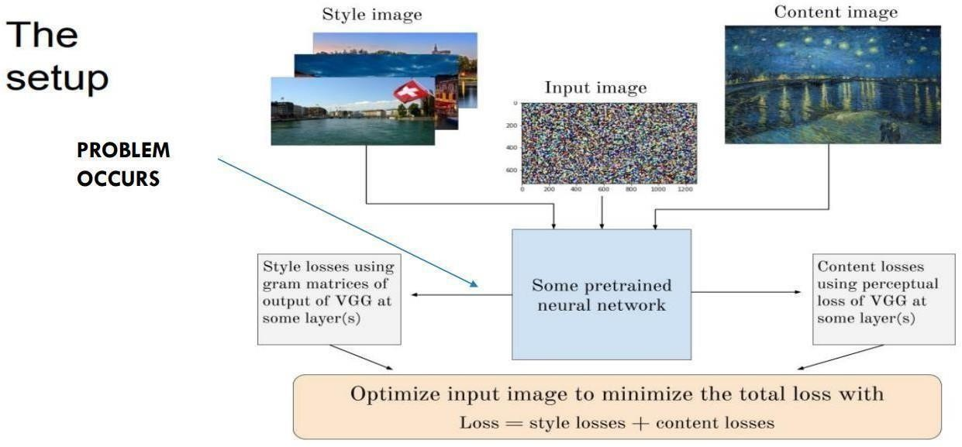

**Fig 1.1:** It represents the Existing System.

* 1. **Proposed System**

In the proposed system, we aim to create a user-friendly interface for image generation using style transfer, abstracting away technical complexities. We will incorporate state-of-the-art algorithms optimized for speed and efficiency, ensuring high-quality results. Our system will prioritize accessibility, providing tutorials and interactive guides for users of all skill levels. Additionally, we plan to explore novel applications beyond traditional image editing, such as video stylization and 3D rendering. By pushing the boundaries of style transfer, we aim to inspire creativity and innovation in digital art.

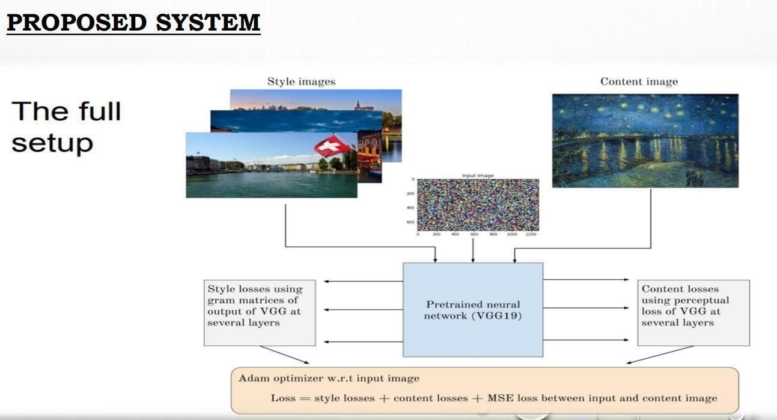

**Fig 1.2:** It represents the Proposed System.

* 1. **Potential Users**

The potential users of our system include artists, designers, photographers, and enthusiasts interested in creative image manipulation. Additionally, professionals in fields like advertising, marketing, and entertainment could benefit from our system for generating visually striking content. Educational institutions may also find value in incorporating our system into their curriculum for teaching concepts of deep learning and image processing. Furthermore, researchers in computer vision and artificial intelligence could utilize our system for experimentation and prototyping. Ultimately, our goal is to cater to a diverse range of users, from beginners to experts, who are passionate about exploring the intersection of art and technology.

* 1. **Unique features of the System**
     + **End-to-End Learning**: Deep learning-based image generation systems often learn to generate images directly from raw data, such as pixels, without the need for handcrafted features or explicit programming of image generation rules.
     + **Hierarchical Feature Representation**: These systems learn to represent images in a hierarchical manner, where lower layers capture basic features like edges and textures, and higher layers capture more complex features like objects and scenes.
     + **Transfer Learning and Pre-trained Models**: Transfer learning allows models trained on one dataset to be adapted for use on another, often leading to more efficient and effective image generation, especially when training data is limited.
     + **Generative Adversarial Networks (GANs)**: GANs are a unique framework in which a generator network learns to generate images that are indistinguishable from real images, based on feedback from a discriminator network that tries to differentiate between real and generated images.
     + **Unsupervised and Self-supervised Learning**: Some image generation systems can learn from unlabeled data or with minimal supervision, making them more adaptable to diverse datasets and potentially reducing the need for labeled training examples.
  2. **Demand for the product**

The demand for image generation products has been steadily increasing across various industries and applications. In the field of entertainment and media, there is a growing need for realistic computer-generated imagery (CGI) for movies, video games, virtual reality (VR), and augmented reality (AR) applications. Image generation is also crucial in fields such as design, architecture, and fashion, where visualizations and mock- ups play a significant role in the creative process.

Moreover, image generation has applications in scientific research, where simulations and visualizations help researchers understand complex phenomena. In education, image generation can enhance learning experiences through interactive visualizations and simulations.

Overall, the demand for image generation products is driven by the need for realistic, immersive, and interactive visual content across various industries and applications, contributing to advancements in technology and enhancing user experiences.

* 1. **Protection of Idea**

To protect the idea of image generation, especially within the context of deep learning and neural networks, it is essential to consider legal strategies such as patents, copyrights, trade secrets, non-disclosure agreements (NDAs), and trademarks. Patents can protect specific implementations or technical aspects of image generation algorithms if they are novel, non-obvious, and have utility. Copyright can protect the expression of image generation technology, including code, algorithms, and visual outputs.

Trade secrets can be used to keep image generation methods and algorithms confidential, but this requires strict confidentiality measures. NDAs can prevent unauthorized disclosure or use of image generation ideas when sharing them with others. Trademarks can protect unique brands or logos associated with image generation technology. Consulting with a legal professional specializing in intellectual property is recommended to determine the best strategy for protecting image generation ideas.

# Literature Review

**CHAPTER - 2**

**ANALYSIS PHASE**

Neural Style Transfer (NST) stands at the forefront of transformative image processing techniques in computer vision, offering a powerful avenue for artistic expression. The fundamental objective of NST is elegantly encapsulated in the abstract: to generate visually captivating images by amalgamating the content of a target image with the stylistic features of a reference image. [1]

In the journey towards creating visually appealing transformations, deep neural networks have played a pivotal role, marking significant strides in the realm of artistic applications and augmenting visual creativity. The abstract introduces this landscape of possibilities, setting the stage for a nuanced exploration of the intricate processes that underlie NST. [2]

Deep neural networks, particularly convolutional neural networks (CNNs), form the backbone of NST methodologies. The abstract underscores their importance in capturing hierarchical features and representations essential for effective style extraction. Specifically, the paper delves into the utilization of pre-trained CNNs, such as VGG-19, as feature extractors, facilitating the extraction of content and style information from input images. [3]

The paper navigates through the challenges associated with NST, emphasizing the careful definition and optimization of a content loss function. This function is identified as a linchpin for preserving the underlying structure of the target image during style transfer, and the abstract sheds light on its role in ensuring the fidelity of the artistic transformation. [4]

As the research progresses, the computational complexity of NST comes to the fore, prompting a thoughtful exploration of optimization strategies to strike a balance between computational efficiency and image quality. The conclusion echoes this sentiment, reflecting with the desire for high-quality stylized images. [5]

The experimental section of the paper unfolds, showcasing the versatility of the proposed NST model across an array of artistic styles. The abstract provides a glimpse into these experiments, highlighting the model's adaptability to diverse input conditions and its ability to produce visually stunning results that resonate with the chosen stylistic references. [6]

The conclusion of the paper serves as a reflective culmination, synthesizing the key findings and contributions. It recognizes the triumphs of NST but also acknowledges the inherent challenge of objectively evaluating the artistic quality of generated images. This introspective moment sparks a call for further research into refined metrics that align more closely with human perception. [7]

Beyond the technical intricacies, the conclusion broadens the perspective, envisioning the practical implications of NST. It foresees the integration of NST into main stream image editing tools and applications, democratizing artistic expression and inviting a wider audience to partake in the realm of digital creativity. [8]

The concluding remarks extend an invitation to the research community to collaborate on the establishment of standardized benchmarks and evaluation metrics for NST algorithms. This collaborative spirit reflects the acknowledgment that advancing the field requires collective efforts in defining benchmarks that align with both computational metrics and human aesthetic sensibilities. [9]

In summary, the paper not only contributes substantively to the evolving landscape of neural style transfer but also serves as a catalyst for inspiring new avenues of research. The paper positions NST at the nexus of computer vision, psychology, and art theory, fostering a holistic understanding of image aesthetics and pushing the boundaries of digital art. [10]

The exploration of perceptual loss functions in the conclusion adds depth to discussion, emphasizing importance of aligning computational metrics with human perception. This nuanced approach reflects the paper's commitment to a evaluation of artistic quality in the realm of neural style transfer. [11]

The abstract eloquently summarizes the research's core methodology, highlighting the incorporation of pre-trained CNNs for feature extraction. This critical step allows the model to distill content and style information effectively, paving the way for a seamless fusion of artistic styles in the generated images. [12]

Delving into the realm of optimization, the paper in the abstract introduces strategies to address the computational complexity inherent in NST. The conclusion expands on this, acknowledging the ongoing efforts to strike an optimal balance between computational efficiency and the fidelity of stylized image outputs. [13]

Style interpolation techniques, briefly mentioned in the conclusion, open the door to a fascinating exploration of blending multiple reference images seamlessly. This aspect of NST introduces the potential for generating entirely new and novel artistic styles through the harmonious fusion of diverse influences. [14]

As the paper concludes, it gracefully acknowledges the interdisciplinary nature of NST. This recognition prompts a broader vision that envisions crossroads with fields like psychology and art theory, where the convergence of computational and artistic principles can lead to richer, more nuanced expressions. [15]

A noteworthy aspect highlighted in the abstract is the proposed methodology's adaptability across various artistic styles. The conclusion expands on this, emphasizing the model's versatility in accommodating different input conditions, showcasing its ability to produce compelling stylized outputs across a spectrum of artistic preferences. [16]

The abstract succinctly captures the essence of the paper's contributions, emphasizing the advancements made in enhancing both the efficiency and artistic fidelity of neural style transfer. This sets the tone for the conclusion, which reflects on these contributions in the context of the evolving landscape of computer vision. [17]

Reflecting on the challenges discussed throughout the paper, the conclusion underscores the need for continuous exploration and refinement of NST models. This forward-looking perspective invites researchers to delve deeper into the nuances of style representation and transfer, boundaries of what NST can achieve. [18]

The concluding remarks of the paper express optimism about the future of NST. Envisioning its integration into real-time applications and collaborative platforms, the paper foresees a future where neural style transfer becomes an accessible tool for individuals, ushering in a new era of democratized digital creativity. [19]

In summary, the paper not only contributes valuable insights to the existing body of knowledge on neural style transfer but also serves as a beacon guiding future research endeavors. By combining technical rigor with a visionary outlook, the paper has left an indelible mark on the landscape of computer vision, inspiring researchers to explore the endless possibilities within the realm of neural style transfer. [20]

* 1. **Requirement analysis**

The requirement analysis for image generation using style transfer involves pinpointing the system's core objectives, stakeholders, and functional and non-functional requirements. The primary goal is to create a system that seamlessly merges the artistic style of one image with the content of another. End-users, such as artists and designers, will interact with the system, while developers will construct it, and administrators will manage its deployment. Functional requirements entail features like image input, style transfer algorithm implementation, parameter adjustment, preview, and efficient output generation. Non-functional requirements encompass aspects such as performance, accuracy, scalability, user interface design, error handling, security, and resource optimization. Constraints may include computational resources, data storage, legal considerations, and compatibility. Use cases vary from generating artwork inspired by famous artists to applying thematic styles to photographs for social media. System architecture choices, including client-server setups or standalone applications, are influenced by these requirements, with suitable programming languages and frameworks selected to meet the project's objectives effectively. This analysis forms the foundation for subsequent design and development efforts.

## Functional requirement analysis

Functional requirements for image generation using style transfer entail enabling users to upload both content and style images, either locally or via URLs. The system should employ a style transfer algorithm, offering users the flexibility to adjust parameters like style weight and learning rate through intuitive controls. After stylization, users should preview the result and have options to download or share the image. Efficient processing, error handling, compatibility with various formats, and comprehensive documentation are vital for a smooth user experience. These functionalities collectively empower users to create stylized images seamlessly.

* + - * **Image Input:**
        1. The system should allow users to upload both a content image and a style image.
        2. Users should be able to select images from their local device or provide URLs for online images.
      * **Style Transfer Algorithm:**
        1. Implementation of the style transfer algorithm, such as Neural Style Transfer (NST) or Cycle GAN, enabling the transfer of style from the style image to the content image.
        2. The system should facilitate the selection of different style transfer models or methods, depending on user preferences.
      * **Parameter Adjustment:**
        1. Users should have the ability to adjust parameters governing the style transfer process.
        2. Parameters may include style weight, content weight, learning rate, and other relevant settings.
        3. The system should provide intuitive controls for parameter adjustment, such as sliders or input fields.
      * **Output:**

1. The system should generate and deliver the stylized image to the user in a preferred format (e.g., PNG, JPEG).
2. Users should have the option to download the stylized image or share it directly on social media platforms.
   * **Performance:**
3. Ensure efficient processing of image data, especially for high- resolution images or real-time stylization.
4. The system should provide feedback on processing progress to keep users informed about the status of their requests.
   * **Error Handling:**
     1. Implement robust error handling mechanisms to gracefully manage issues such as invalid input images, network errors, or algorithm failures.
     2. Provide clear error messages and guidance to help users resolve problems effectively.
   * **User Authentication and Authorization:**
     1. If applicable, the system should include user authentication and authorization mechanisms to control access to certain features or limit usage based on user roles.
     2. Uploading content and style images.
     3. Implementing the style transfer algorithm.
     4. Displaying the stylized output to the user.
     5. Providing options for users to adjust parameters or select styles.

## User requirements

User requirements for image generation using style transfer involve understanding the needs, preferences, and expectations of the individuals who will interact with the system. These requirements focus on the features and capabilities that users desire to achieve their goals effectively.

* + - * No need of any heavy requirements.
      * Needed to upload a content image and style image.
      * **Ease of Use**- Users expect an intuitive interface that allows them to upload content and style images effortlessly, adjust parameters intuitively, preview results, and download or share stylized images without confusion.
      * **Security and privacy**- Users expect their uploaded images and personal data to be handled securely, with measures in place to protect their privacy and prevent unauthorized access or misuse of their information.
      * **Customization Options**: Users desire the ability to fine-tune parameters such as style strength, content preservation, and color adjustments to achieve the desired stylization effect tailored to their specific preferences.
      * **Accessibility**- Users with disabilities may require features such as screen reader compatibility, keyboard navigation, or alternative input methods to ensure equal access to the system's functionality.
      * **Educational Resources**- Users may appreciate access to tutorials, guides, or documentation explaining the style transfer process, parameter adjustments, and tips for achieving optimal results, especially for those new to the concept.
    1. **Non-functional requirement analysis**

Non-functional requirements for image generation using style transfer include efficient processing for timely results, scalability to handle varying user loads, accuracy in preserving artistic styles and content details, a user-friendly interface with robust error handling, and stringent security measures to protect user data.

* + - * **Performance**- The system should be capable of processing images efficiently, delivering stylized results within a reasonable timeframe, even when handling high- resolution images or complex style transfer algorithms.
      * **Scalability-** The system should be designed to handle varying levels of user traffic and accommodate potential increases in workload without significant degradation in performance. It should scale seamlessly with growing demand
      * **Usability**- The user interface should be intuitive and user-friendly, allowing users to navigate through the stylization process easily. Clear instructions, helpful tooltips, and visual feedback can enhance usability.
      * **Reliability-** The system should be robust and resilient, capable of handling errors gracefully and recovering from failures without compromising the user experience. It should minimize downtime and ensure consistent availability.
      * **Security-** Measures should be in place to protect user data, prevent unauthorized access, and safeguard against potential security threats such as data breaches or malicious attacks. This includes secure handling of uploaded images and user information.

## System requirements

The system requires sufficient hardware resources like CPU, GPU, RAM, and storage. Software components include Python with frameworks like TensorFlow, image processing libraries, and compatibility with various operating systems. Stable internet connectivity and popular web browser support are necessary environmental factors. Dependencies on third- party libraries should be managed, and performance metrics like processing speed must be optimized for efficient operation.

* + - * **Hardware:**
        1. Adequate computational resources, including CPU and GPU, for efficient image processing.
        2. Sufficient RAM to handle large image datasets and processing operations.
        3. Adequate storage space for storing images and system files.
      * **Software:**
        1. Programming languages like Python with frameworks such as TensorFlow, PyTorch, or Keras for implementing style transfer algorithms.
        2. Image processing libraries for manipulating images and handling various formats.
        3. Web development tools if the system includes a web-based interface.
        4. Compatibility with operating systems like Windows, macOS, or Linux.
      * **Environment:**
        1. Stable internet connectivity, especially for cloud-based services or online image retrieval.
        2. Compatibility with popular web browsers and devices.
        3. Consideration of environmental factors like temperature and humidity for physical deployments.
  1. **Module description**

It describes the major functionalities of each module.

* + 1. **TensorFlow (or Py Torch):**

1. **Description**: Deep learning frameworks that provide tools and abstractions for building and training neural networks.
2. **Use**: Define and train the style transfer model. TensorFlow and PyTorch offer high-level APIs that simplify the implementation.
   * 1. **NumPy:**
3. **Description:** A library for numerical operations in Python.
4. **Use:** Manipulate and process arrays and matrices, which are fundamental for image data handling.
   * **OpenCV:**
5. **Description:** A computer vision library with tools for image and video processing.
6. **Use:** Read, manipulate, and display images. Useful for preprocessing and post-processing steps.
   * **PIL (Pillow):**
     1. **Description:** Python Imaging Library (Pillow) is a library for opening, manipulating, and saving various image file formats.
     2. **Use:** Handle image-related tasks such as loading, saving, and basic transformations.
   * **Matplotlib:**
     1. **Description**: A 2D plotting library for Python.
     2. **Use:** Visualize images, plots, and other graphical representations during the development process.
   * **Jupyter Notebooks**:
     1. **Description**: An interactive computing environment.
     2. **Use:** Develop and document code in an interactive and visual manner. Useful for experimenting with different parameters.

# Feasibility Study

The feasibility study for image generation using style transfer examines the practicality of developing such a system across technical, economic, and operational dimensions. On a technical level, it assesses the availability of suitable technology and resources for implementing style transfer algorithms, considering factors like computational requirements and software compatibility. Economically, the study evaluates the costs associated with development, including hardware, software, and personnel expenses, against potential benefits and returns on investment.

* Technical feasibility
* Operational feasibility
* Market feasibility
* Financial feasibility

## Technical feasibility

Image generation via style transfer relies on deep learning, particularly Convolutional Neural Networks (CNNs), to extract features from both the style and content images. These features, encompassing textures, colors, and shapes, are then represented and optimized to synthesize a new image merging the content of one with the style of another. The process involves iteratively adjusting pixel values in an initially random image to minimize differences between its features and those of the content and style images, guided

by loss functions. Variants like instance normalization and enhancements improve efficiency. While style transfer can be computationally intensive, advancements in hardware, such as GPUs and TPUs, coupled with optimization techniques, render it feasible. Its applications span diverse domains, including artistic rendering, photo editing, and video processing. The integration of style transfer into mobile apps and online platforms enhances its accessibility and usability, catering to a broader audience. Despite its complexity, style transfer continues to evolve with ongoing research aimed at enhancing its effectiveness and efficiency.

## Operational feasibility

Operational feasibility of image generation using style transfer encompasses several crucial considerations for its successful implementation. Firstly, organizations need to evaluate the availability of resources, including hardware, software, and skilled personnel, ensuring they can support the deployment and maintenance of style transfer models. Additionally, assessing technical capabilities is vital to ascertain if the organization possesses the requisite expertise to effectively utilize and manage these sophisticated AI technologies. Data availability is another critical aspect, requiring access to suitable datasets for training and fine-tuning the style transfer models. Integration with existing systems and workflows must be considered to ensure seamless adoption and compatibility. Scalability is also important, ensuring that the solution can accommodate increasing demands over time. Adequate training and support for personnel are essential to empower them with the necessary skills to operate the style transfer solution efficiently.

Moreover, conducting a comprehensive cost-benefit analysis is crucial to weigh the economic feasibility of implementation against potential benefits.

Finally, adherence to regulatory and ethical guidelines governing image data and AI technologies is imperative to mitigate risks and ensure responsible use. By addressing these aspects, organizations can determine the operational feasibility of integrating image generation using style transfer into their workflows effectively.

* + 1. **Market feasibility**

Market feasibility for image generation using style transfer is robust, driven by the increasing demand for visually compelling content across various industries and applications. This demand is propelled by advancements in artificial intelligence and deep learning technologies, as well as the widespread use of image-based social media platforms and online content creation tools. Businesses across sectors such as marketing, advertising, design,

entertainment, and e-commerce recognize the value of visually appealing content in engaging audiences and driving conversions.

Additionally, the democratization of image editing tools through mobile apps and cloud- based platforms has expanded the market reach to include both professionals and amateur creators. Moreover, the versatility of style transfer algorithms allows for a wide range of applications, from artistic expression to brand enhancement and product customization. As a result, the market for image generation using style transfer is poised for continued growth, offering ample opportunities for innovation and business expansion.

However, challenges such as ensuring algorithmic fairness, addressing ethical considerations, and adapting to evolving consumer preferences and technological advancements will need to be navigated to capitalize fully on the market potential. Overall, the market feasibility of image generation using style transfer is high, with strong demand and a diverse range of opportunities across industries driving its growth and adoption.

## Financial feasibility

Financial feasibility for image generation using style transfer depends on various factors, including the cost of technology, infrastructure, and talent, balanced against potential revenue streams and cost savings. Initial investment in hardware, software, and skilled personnel for implementing style transfer solutions can be significant, particularly for businesses seeking to develop in-house capabilities.

However, advancements in cloud computing and the availability of pre-trained models have lowered entry barriers, allowing organizations to access style transfer technology without large upfront investments. Additionally, the scalability of cloud-based solutions enables businesses to adjust resources based on demand, reducing operational costs.

Revenue generation opportunities for style transfer solutions stem from diverse sources, including product sales, subscription models, licensing fees, and service offerings. Businesses can monetize style transfer applications by integrating them into existing products or developing standalone solutions tailored to specific industries or use cases. For example, software companies can offer photo editing tools with style transfer capabilities, while marketing agencies can provide branded content creation services using style transfer techniques.

# Process model used

The Waterfall model follows a structured and sequential process for software development, where each phase flows into the next in a linear fashion. It begins with requirements gathering, during which stakeholders' needs and objectives are documented. Once requirements are established, the system design phase follows, wherein the architecture and functionality of the software are specified in detail. This is succeeded by the implementation phase, where developers write code and build the system according to the design specifications. Subsequently, the software undergoes rigorous testing to ensure it meets the specified requirements and functions correctly. Upon successful testing, the software is deployed to users or customers, marking the deployment phase. Finally, the maintenance phase involves ongoing support and updates to address defects and enhance functionality as needed. While the Waterfall model provides a systematic approach to software development, its linear nature can pose challenges in accommodating changes or responding to evolving requirements once development is underway.

**Principles of Waterfall model:**

* Sequential phases without overlap.
* Structured and systematic methodology.
* Assumption of requirement stability.
* Emphasis on documentation at each phase.
* Progression gated by formal reviews.
* Minimal customer involvement after initial requirements gathering.
* Aim for predictability and control.
* Quality assurance activities at each stage.
* Rigid and inflexible nature.
* Limited scope for ongoing risk management.

**PROCESS MODEL**

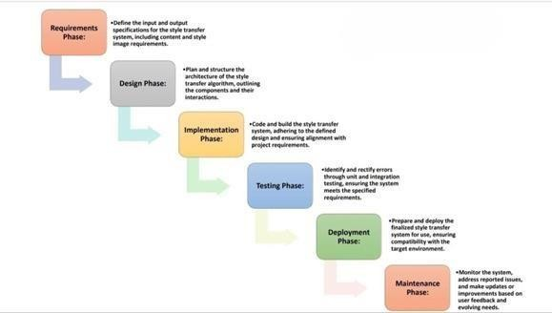

**Fig 2.1:** Process of Waterfall Model

In the Waterfall model, the software development process progresses through sequential phases, each building upon the outcomes of the previous stage. Initially, requirements gathering is conducted to define the functionalities and objectives of the software. Subsequently, the system design phase follows, where the modules and architecture of the software are planned based on the gathered requirements. Once the design is finalized, the development phase commences, during which the software is implemented according to the specified design, incorporating machine learning algorithms for predictive operations, as in this case. After development, beta testing is performed to assess the software's efficiency and identify any defects or issues. If the software meets the required standards and functions as expected, it proceeds to the release phase, where the finalized version is deployed for user access. Following deployment, the software undergoes maintenance, wherein updates and enhancements are made based on user feedback and changing requirements.

# Hardware and software requirements

The following are the software and hardware requirements to execute or to implement our project:

Software Requirements: (for development)

For developing the application, the following are the Software Requirements:

* TensorFlow
* PyTorch
* Keras
* GANs and VAEs
* Image Processing Libraries

**Operating Systems supported: (for end user)**

* Windows 7 or higher
* MacOs
* Linux
* Web-based Applications

**Technologies and Languages used to Develop:**

* Deep Learning Frameworks
* Computer Vision Libraries
* Web Technologies
* Java

**Debugger and Emulator:**

* TensorFlow Debugger
* PyTorch Debugger
* Android Emulator
* IOS Emulator
* Web Browser Emulator

**Hardware Requirements:**

For developing the application, the following are the Hardware Requirements:

* A multi-core CPU is requires
* At Least RAM: 16GB
* Space on Hard Disk: minimum 100GB
* GPU (Graphics Processing Unit)
* Storage

# SRS Specification

The Software Requirements Specification (SRS) for image generation software outlines the essential features, functionalities, and constraints of the proposed system. This document serves as a blueprint for the development team, guiding the design, implementation, and testing phases of the project. The image generation software aims to provide users with a versatile tool for creating images using various algorithms and techniques. It caters to a wide range of applications, including art generation, data augmentation, and content creation.

Specific requirements are detailed next, covering both functional and non-functional aspects of the software. Functional requirements outline the specific features and capabilities of the image generation software, such as input options, generation techniques, customization capabilities, and output formats. Non-functional requirements encompass quality attributes such as performance, usability, reliability, security, compatibility, and maintainability.

## Benefits of a good SRS:

* You save time
* You save money
* You have better cooperation with the development team
* You feel confident

**Overview:**

Image generation, a multifaceted field within computer science and artificial intelligence, involves the creation of images using computational methods rather than direct photographic capture. This process encompasses a diverse array of techniques, ranging from mathematical algorithms to deep learning models. These methods allow for the synthesis of images with specific characteristics or objectives, spanning from artistic rendering to data- driven synthesis. By harnessing mathematical models, machine learning algorithms, and digital manipulation techniques, image generation can produce visuals that range from highly realistic to abstract and surreal.

In recent years, deep learning techniques have revolutionized image generation, particularly through approaches such as Generative Adversarial Networks (GANs) and Variational Autoencoders (VAEs). These models can learn to generate realistic images by analyzing large datasets of existing images and learning their underlying patterns and structures. This capability has unlocked numerous applications across various domains, including art, entertainment, medicine, and computer vision.

Artistic rendering utilizes image generation techniques to create digital artwork, generate visual effects in movies and video games, and produce synthetic images for design and illustration. In machine learning, data augmentation techniques leverage image generation to expand training datasets, improve model performance, and enhance generalization. Content creators utilize image generation tools to produce visually compelling images for marketing materials, social media, and digital advertising.

Moreover, image generation plays a significant role in medical imaging, where it assists in synthesizing realistic anatomical structures, generating simulated medical images for training and education, and enhancing diagnostic imaging. Additionally, image generation algorithms are employed in image editing and enhancement tasks, enabling manipulation, noise reduction, inpainting, and style transfer.

**Purpose:**

The purpose of this project is to develop a robust and versatile image generation software solution that leverages cutting-edge computational techniques to produce high- quality images. At the core of this endeavor lies the exploration of various image generation methodologies, including advanced deep learning models such as Generative Adversarial Networks (GANs), Variational Autoencoders (VAEs), and style transfer algorithms. By delving into these techniques, the project aims to unravel their potentials, limitations, and real-world applications.

Central to the project's objectives is the creation of a user-friendly platform that empowers users to effortlessly generate images tailored to their specific needs and preferences. Whether for artistic endeavors, data augmentation tasks, or content creation purposes, the software endeavors to offer intuitive controls, comprehensive features, and customizable options to cater to a diverse range of user requirements.

Moreover, the project emphasizes the enhancement of image quality and realism, striving to optimize algorithms, fine-tune parameters, and explore novel approaches to elevate the fidelity, resolution, and aesthetic appeal of generated images. This pursuit is complemented by an exploration of user-friendly features and interfaces, ensuring accessibility and ease- of-use for individuals with varying levels of technical proficiency.

**CHAPTER - 3**

**DESIGN PHASE**

**Input design:**

* + Select a content image related to input design, such as a flowchart or a user interface layout. Then, choose a style image that you'd like to apply to the content image. This could be an artwork, a photograph, or any image with distinct style characteristics.
  + Before applying style transfer, preprocess both the content and style images. Resize them to the same dimensions and normalize their pixel values.
  + Utilize a style transfer algorithm, such as Neural Style Transfer (NST), to apply the artistic style of the style image onto the content image. There are many pre-trained models and libraries available for style transfer, such as TensorFlow, PyTorch, or online tools like DeepArt.io.
  + Experiment with different parameters like style weight, content weight, and learning rate to achieve the desired style transfer effect. These parameters affect how much influence the style image has on the final output.
  + Once style transfer is complete, postprocess the resulting image if necessary. This might involve adjusting brightness, contrast, or sharpness to enhance the visual appeal.
  + Save the final stylized image and evaluate it to ensure it effectively combines the content of the input design with the style of the chosen image.

**Output design:**

* + Select a content image that represents the output design conceptually. This could be a visualization of data, a user interface displaying processed information, or any relevant imagery. Then, choose a style image that embodies the artistic style you want to apply to the output image.
  + Resize both the content and style images to the same dimensions and normalize their pixel values. This ensures consistency during the style transfer process.
  + Utilize a style transfer algorithm to blend the style of the chosen image onto the content image. You can use pre-trained models available in deep learning

libraries like TensorFlow or PyTorch, or you can use online style transfer tools.

* + Experiment with different parameters such as style weight, content weight, and learning rate to achieve the desired style transfer effect. These parameters influence how strongly the style image's characteristics are imposed on the output image.
  + After style transfer is complete, you may want to perform additional post- processing to refine the output image. This could involve adjusting brightness, contrast, or sharpness to enhance visual appeal or clarity.
  + Save the final stylized image and evaluate it to ensure it effectively combines the content of the output design with the stylistic elements of the chosen image. Make any necessary adjustments to achieve the desired result.

**3.1. Design concepts & Constraints**

The set of fundamental software design concepts are as follows:

1. **Abstraction**

At its core, image generation using style transfer involves merging the content of one image with the artistic style of another. This process can be abstracted into the following steps:

**Content Extraction:**

* + Extract the content features from the target image, preserving its essential visual elements and structures.

**Style Extraction:**

* + Extract the style features from the style image, capturing its unique artistic characteristics such as colors, textures, and patterns.

**Feature Combination:**

* + Combine the content and style features in a way that preserves the content of the target image while incorporating the artistic style of the style image.

**Optimization:**

* + Utilize optimization techniques to iteratively adjust the combined features to minimize the difference between the stylized image and the target style, while also ensuring content preservation.

**Output Generation:**

* + Generate the final stylized image by applying the optimized features to the content structure of the target image, resulting in a visually appealing composition that reflects both the content and style elements.

1. **Architecture**

Image generation using style transfer typically involves combining the content of one image with the style of another image. The process often relies on Convolutional Neural Networks (CNNs) to extract content and style features from the input images and then synthesizing a new image that matches the content of one image while adopting the style of another. Here's a basic overview of how this process works:

**Load Content and Style Images:**

* + You start by loading the content image and the style image that you want to use for generating the new image.

**Define Neural Network:**

* + Next, you use a pre-trained CNN, typically VGG or a variant thereof, to extract both content and style features from the input images. The network is usually truncated at a certain layer to separate content and style information.

**Compute Content and Style Representations:**

* + Pass the content and style images through the neural network to extract their respective content and style features at the selected layers.

**Define Loss Functions:**

* + Define loss functions that measure the difference between the content of the generated image and the content image, as well as the difference between the style of the generated image and the style image.

**Optimization:**

* + Use an optimization algorithm (often gradient descent) to minimize the total loss, which is a combination of content loss and style loss, by adjusting the pixel values of the generated image.

**Generate Image:**

* + Iterate through the optimization process until the generated image adequately captures the content of the content image with the style of the style image.

1. **Patterns**
   * In the context of image generation using style transfer, several patterns emerge from the underlying architecture and techniques employed. There are some following steps:

**Feature Extraction Pattern:**

* + This pattern involves extracting high-level features from both the content and style images using pretrained convolutional neural networks (CNNs).
  + Features from intermediate layers of the CNNs are utilized to capture content representations and style characteristics, respectively.

**Loss Function Pattern:**

* + Loss functions, such as content loss and style loss, are central to the optimization process in style transfer.
  + Content loss measures the difference in content features between the generated image and the target image.
  + Style loss measures the difference in style features between the generated image and the style image.
  + The total variation loss encourages smoothness in the generated image.

**Optimization Pattern:**

* + Gradient descent optimization is employed to iteratively adjust the pixel values of the generated image to minimize the combined loss function.
  + The process involves updating the generated image in each iteration until convergence is achieved.

**Initialization Pattern:**

* + The generated image is initialized either as random noise or as a copy of the target image.
  + This initialization pattern influences the starting point of the optimization process and can affect the final result.

**Representation Pattern:**

* + Style transfer enables the creation of images that represent a combination of content from one image and style from another.
  + The resulting images often exhibit a visually pleasing blend of content and artistic style, creating unique and appealing compositions.

**Iteration Pattern:**

* + Style transfer typically involves multiple iterations of optimization to refine the generated image.
  + Each iteration updates the pixel values of the generated image based on the gradients computed from the loss function.

**Convergence Pattern:**

* + The optimization process continues until convergence is achieved, meaning that further iterations do not significantly improve the generated image.
  + Convergence indicates that the generated image has effectively combined the content and style of the input images.

1. **Modularity**

In the context of image generation using style transfer, modularity refers to the degree to which the system can be decomposed into independent and reusable components. Here's how modularity can be applied:

**Preprocessing Modules:**

* + Modularity can be introduced by separating preprocessing tasks such as image resizing, normalization, and feature extraction into modular components.
  + Each preprocessing module can perform a specific task independently, allowing for flexibility and reusability across different style transfer implementations.

**Feature Extraction Modules:**

* + Modularizing the feature extraction process enables the independent extraction of content and style features from the input images.
  + Content feature extraction and style feature extraction can be implemented as separate modules, each responsible for capturing relevant information from the respective images.

**Loss Function Modules:**

* + The definition and computation of loss functions, including content loss, style loss, and total variation loss, can be modularized.
  + Each loss function module encapsulates the logic for calculating a specific type of loss, promoting code reuse and maintainability.

**Optimization Modules:**

* + Modularizing the optimization process allows for flexibility in the choice of optimization algorithm and parameters.
  + Different optimization algorithms, such as gradient descent variants or metaheuristic algorithms, can be implemented as separate modules, facilitating experimentation and comparison.

**Output Generation Modules:**

* + The generation of the final stylized image can be modularized to separate the generation logic from the optimization process.
  + Modular output generation allows for customization of post-processing steps and integration with external systems or applications.
  + By incorporating modularity into the design of image generation using style transfer, developers can achieve several benefits:

**Benefits:**

**Flexibility:**

* + Modular components can be easily modified or replaced to accommodate changes in requirements or preferences.

**Scalability:**

* + Independent modules can be reused across different style transfer implementations, reducing development effort and promoting code maintainability.

**Interchangeability:**

* + Modular components can be interchanged or combined to explore different configurations or experiment with alternative techniques.

**Testability:**

* + Modular components facilitate unit testing and validation, as each component can be tested independently of others.

1. **Information hiding**

Information hiding is a design principle that emphasizes encapsulating the details of implementation within individual modules or components, while exposing only the necessary interfaces or abstractions to other parts of the system. In the context of image generation using style transfer, information hiding can be applied to improve modularity and maintainability. Here's how information hiding can be incorporated:

**Abstraction of Components:**

* + Hide the internal details of individual modules or components by defining clear and concise interfaces that abstract away implementation details.
  + For example, the feature extraction module can expose a simple interface for extracting content and style features, hiding the complexity of underlying CNN architectures and operations.

**Encapsulation of Logic:**

* + Encapsulate the logic and functionality of each module within its own scope, limiting direct access to internal variables or functions from external components.
  + For instance, the loss function module can encapsulate the logic for calculating content loss, style loss, and total variation loss, exposing only the necessary methods for computing and aggregating losses.

**Data Hiding:**

* + Limit access to internal data structures or variables by enforcing private or protected access modifiers within each module.
  + This prevents unintended modifications or dependencies on internal state, promoting encapsulation and reducing coupling between modules.

**Interface Design:**

* + Design clear and intuitive interfaces for interacting with each module, focusing on abstraction and simplicity to hide unnecessary implementation details.
  + For example, the optimization module can provide a straightforward interface for configuring optimization parameters and initiating the optimization process, hiding the specifics of gradient descent or other optimization algorithms.

**Separation of Concerns:**

* + Separate the concerns of different modules to promote cohesion and minimize dependencies between unrelated components.
  + Each module should be responsible for a specific aspect of the style transfer process, such as preprocessing, feature extraction, loss computation, optimization, or output generation, with clear boundaries and minimal overlap.

1. **Functional independence**

Functional independence in the context of image generation using style transfer refers to the degree to which different components or modules within the system operate autonomously and can function independently of each other. Here's how functional independence can be achieved:

**Modular Design:**

* + Decompose the system into modular components, each responsible for a specific aspect of the style transfer process.
  + Modules such as preprocessing, feature extraction, loss computation, optimization, and output generation should operate independently, with well-defined interfaces for interaction.

**Loose Coupling:**

* + Minimize dependencies between modules to reduce coupling and promote independence.
  + Each module should rely only on the interfaces provided by other modules, rather than accessing their internal implementations directly.
  + This allows for easier modification or replacement of individual modules without affecting the functionality of the entire system.

**Encapsulation:**

* + Encapsulate the internal logic and state of each module to shield it from external interference.
  + Modules should expose only the necessary interfaces and hide implementation details, ensuring that changes to one module do not inadvertently impact others.

**Abstraction:**

* + Define clear and abstract interfaces for interaction between modules, focusing on what each module provides rather than how it achieves it.
  + This allows modules to be swapped out or replaced with alternative implementations without affecting the overall functionality of the system.

**Single Responsibility Principle (SRP):**

* + Ensure that each module has a single responsibility or purpose, reducing complexity and promoting functional independence.
  + Modules should be focused on performing specific tasks related to style transfer, such as feature extraction or optimization, rather than trying to handle multiple responsibilities.

**Testing and Validation:**

* + Test each module independently to verify its functionality and behavior in isolation.
  + Unit tests can be used to validate the correctness of individual modules, ensuring that they produce the expected outputs given certain inputs.
  + By promoting functional independence through modular design, loose coupling, encapsulation, abstraction, adherence to the single responsibility principle, and thorough testing, developers can create more flexible, maintainable, and scalable systems for image generation using style transfer.

1. **Refinement**

Image generation using style transfer typically involves two main steps: extracting the style from one image (the style image) and applying it to another image (the content image). Here's a basic overview of the process and its refinement:

**Layer Selection:**

* + Experiment with different layers in the CNN for extracting style and content features. Different layers capture different levels of abstraction, leading to variations in the generated images.

**Loss Weights:**

* + Tune the weights assigned to the style and content loss terms in the overall loss function. Adjusting these weights can control the balance between preserving the content of the content image and incorporating the style of the style image.

**Optimization Parameters:**

* + Experiment with optimization parameters such as learning rate, number of iterations, and optimization algorithm (e.g., Adam, L-BFGS) to find the best settings for generating high-quality images.

**Post-processing:**

* + Apply post-processing techniques such as histogram equalization, denoising, or sharpening to refine the generated image further and enhance its visual quality.

By refining these aspects of the style transfer process, you can achieve better results and generate images that effectively blend the content of one image with the style of another.

1. **Refactoring**

Refactoring in the context of image generation using style transfer involves restructuring and improving the design of the system to enhance modularity, maintainability, and extensibility without altering its external behavior. Here are some refactoring techniques that can be applied:

**Module Extraction:**

* + Identify cohesive sets of functionality within the existing codebase and extract them into separate modules or classes.
  + For example, if the preprocessing logic is tightly coupled with the main application code, it can be refactored into a dedicated preprocessing module.

**Interface Definition:**

* + Define clear and abstract interfaces for interacting with different modules, promoting loose coupling and functional independence.
  + Ensure that modules communicate with each other through well-defined interfaces rather than directly accessing each other's internal implementations.

**Encapsulation:**

* + Encapsulate internal implementation details within modules to hide complexity and shield them from external interference.
  + Use access modifiers to restrict access to internal variables and methods, exposing only the necessary interfaces to external components.

**Dependency Injection:**

* + Refactor modules to rely on dependency injection rather than creating dependencies internally.
  + This allows dependencies to be injected at runtime, making it easier to replace or mock dependencies for testing purposes.

**Single Responsibility Principle (SRP):**

* + Review each module to ensure that it adheres to the SRP, with a single responsibility or purpose.
  + If a module is handling multiple responsibilities, refactor it into smaller, more focused modules that each have a single responsibility.

**Code Duplication Removal:**

* + Identify and eliminate code duplication within the system to improve maintainability and reduce the risk of bugs.
  + Extract common functionality into reusable functions or modules, promoting code reuse and consistency.

**Naming and Documentation:**

* + Review and improve naming conventions to make code more readable and self- explanatory.

Document the purpose and usage of each module, class, and function to aid understanding and maintainability.

**Testing and Validation:**

* + Ensure comprehensive test coverage for all refactored code to validate its correctness and behavior.

1. **Design classes**

Designing classes for image generation using style transfer involves encapsulating the various components and functionalities of the system into modular and reusable units. Below are some suggested classes that could be part of the design:

**Preprocessing Module:**

* + Responsible for preprocessing input images before style transfer.
  + Contains methods for tasks such as resizing, normalization, and preparing images for feature extraction.

**Feature Extractor:**

* + Handles the extraction of content and style features from input images.
  + Contains methods for extracting features using pretrained convolutional neural networks (CNNs).

**Loss Function Calculator:**

* + Computes the loss functions used during optimization, including content loss, style loss, and total variation loss.
  + Contains methods for calculating each type of loss based on input features.

**Optimizer:**

* + Manages the optimization process to generate the stylized image.
  + Utilizes optimization algorithms such as gradient descent to iteratively update the pixel values of the generated image.

**Output Generator:**

* + Generates the final stylized image based on the optimized pixel values.
  + Contains methods for post-processing and enhancing the visual quality of the generated image.

**Style Transfer System:**

* + Orchestrates the overall style transfer process by coordinating the execution of different modules.
  + Contains methods for initializing the system, setting parameters, and executing the style transfer algorithm.

**Image Data:**

* + Represents input images and stylized images within the system.
  + Contains attributes such as image data, dimensions, and metadata.

**Configuration Manager:**

* + Manages configuration settings and parameters for the style transfer system.
  + Provides methods for loading, saving, and updating configuration options.

**Logging Module:**

* + Handles logging and output of information during the style transfer process.
  + Provides methods for logging messages, errors, and debug information.

**Utilities:**

* + Contains utility functions and helper methods used across different modules.
  + Provides functionalities such as image loading, saving, visualization, and transformation.
  + These classes encapsulate the various functionalities required for image generation using style transfer and promote modularity, encapsulation, and maintainability. Depending on the specific requirements of the system, additional classes or refinements to existing classes may be necessary. Additionally, proper design patterns such as dependency injection, observer pattern, or factory pattern can be employed to further enhance the flexibility and extensibility of the system.

**Design Constraints**

Design constraints in the context of image generation using style transfer refer to limitations or requirements that influence the design and implementation of the system. These constraints may arise from technical, practical, or business considerations. Here are some common design constraints:

1. **Constraints**

Constraints on available computational resources, such as CPU, GPU, memory, and storage, may limit the complexity and scalability of the style transfer algorithm.

Design decisions must consider the computational overhead of feature extraction, optimization, and other processing steps to ensure efficient resource utilization.

There are some types of constraints are there:

**Time Constraints:**

* + Requirements for real-time or near-real-time image generation may impose constraints on the speed and efficiency of the style transfer process.
  + Design choices must balance the trade-off between computational complexity and processing speed to meet time-sensitive deadlines.

**Quality Constraints:**

* + Quality expectations for the generated images, including factors such as visual fidelity, perceptual similarity, and artistic appeal, may influence the design of the style transfer algorithm.
  + Design decisions must prioritize techniques that produce high-quality results while maintaining efficiency and computational feasibility.

**Input Data Constraints:**

* + Constraints on the characteristics of input images, such as resolution, aspect ratio, color space, and format, may affect the preprocessing and feature extraction stages of the style transfer process.
  + Design choices must accommodate a wide range of input data types and formats to ensure compatibility and flexibility.

**Style Image Constraints:**

* + Requirements for style images, including artistic styles, textures, colors, and compositions, may dictate the choice of style transfer techniques and parameters.
  + Design decisions must consider the diversity and complexity of style images to ensure that the style transfer algorithm can effectively capture and replicate desired styles.

**Security and Privacy Constraints:**

* + Constraints related to security and privacy concerns, such as protection of sensitive data, prevention of unauthorized access, and compliance with privacy regulations, may impact the design of the system.
  + Design choices must include measures to secure input data, protect user privacy, and mitigate risks of data breaches or unauthorized use.

**Platform and Environment Constraints:**

* + Constraints imposed by the deployment platform or environment, such as operating system compatibility, hardware limitations, and network connectivity constraints, may influence the design and implementation of the system.
  + Design decisions must account for platform-specific requirements and limitations to ensure seamless integration and operation in diverse environments.

**Budgetary Constraints:**

* + Budgetary constraints, including costs associated with hardware, software, development resources, and maintenance, may restrict the choice of technologies, tools, and development approaches.
  + Design decisions must align with budgetary considerations to optimize resource allocation and minimize costs while meeting project requirements.

1. **Requirements**

The requirements for image generation using style transfer encompass the functional and non-functional aspects that define the desired behaviour, features, and qualities of the system. There are some common requirements:

1. **Functional Requirements:**

**Style Transfer Functionality:**

* + The system should be capable of transferring the artistic style of a given style image onto a target content image, generating a stylized output image.

**Input Image Handling:**

* + The system should support the processing of input images in various formats, resolutions, and color spaces, ensuring compatibility with a wide range of input data.

**Preprocessing:**

* + The system should preprocess input images to prepare them for style transfer, including tasks such as resizing, normalization, and color space conversion.

**Feature Extraction:**

* + The system should extract content and style features from input images using pretrained convolutional neural networks (CNNs) or other feature extraction techniques.

**Loss Computation:**

* + The system should compute loss functions, including content loss, style loss, and total variation loss, to quantify the difference between the generated image and the target style.

**Optimization:**

* + The system should employ optimization algorithms, such as gradient descent, to iteratively adjust the pixel values of the generated image to minimize the combined loss function.

**Output Generation:**

* + The system should generate the final stylized image based on the optimized pixel values, applying post-processing techniques to enhance visual quality and aesthetics.

1. **Non-functional requirements Performance:**
   * The system should achieve efficient performance in terms of processing speed, memory usage, and computational resources, ensuring timely generation of stylized images.

**Quality:**

* + The system should produce high-quality stylized images that accurately capture the artistic style of the style image while preserving the content of the target image.

**Scalability:**

* + The system should be scalable to handle large volumes of input images and style transfer requests, supporting concurrent processing and efficient resource utilization.

**Robustness:**

* + The system should be robust to variations in input data, handling noise, artifacts, and inconsistencies gracefully to produce reliable and consistent results.

**Flexibility:**

* + The system should be flexible and customizable, allowing users to adjust parameters, select different styles, and experiment with various optimization techniques.

**Compatibility:**

* + The system should be compatible with different platforms, operating systems, and deployment environments, ensuring seamless integration and interoperability.

**Security:**

* + The system should incorporate security measures to protect against unauthorized access, data breaches, and malicious attacks, safeguarding sensitive input data and user privacy.

1. **Compliance**

The compliance requirements for image generation using style transfer may vary depending on the specific application, industry standards, and regulatory frameworks. Here are some common compliance considerations:

**Data Privacy and Security:**

* + Compliance with data privacy regulations such as the General Data Protection Regulation (GDPR) in Europe or the Health Insurance Portability and Accountability Act (HIPAA) in the United States.
  + Ensuring that sensitive user data, including input images and stylized output images, is handled securely and protected from unauthorized access or disclosure.

**Intellectual Property Rights:**

* + Compliance with intellectual property laws and regulations to ensure that the system does not infringe on the copyrights or trademarks of third-party content, including style images.
  + Obtaining appropriate licenses or permissions for the use of copyrighted artworks or other visual content as style references.

**Accessibility Standards:**

* + Compliance with accessibility standards such as the Web Content Accessibility Guidelines (WCAG) to ensure that the system's user interface is accessible to users with disabilities.
  + Providing alternative text descriptions, keyboard navigation support, and other accessibility features for users who rely on assistive technologies.

**Ethical Considerations:**

* + Compliance with ethical guidelines and principles to ensure responsible and ethical use of the system, particularly when generating images with potentially sensitive or controversial content.
  + Adhering to ethical standards for image manipulation and artistic representation, avoiding deceptive or misleading practices.

**Accuracy and Fairness:**

* + Compliance with standards for accuracy and fairness in image generation to prevent biases or discrimination in the stylized output images.
  + Ensuring that the system produces consistent and unbiased results across different demographic groups and input data sets.

**Transparency and Accountability:**

* + Compliance with transparency and accountability requirements to provide users with clear information about how their data is used and processed.
  + Implementing mechanisms for auditing and accountability to track and document the style transfer process, including the choice of style images and optimization parameters.

By addressing these compliance considerations, organizations can develop image generation systems using style transfer that align with legal, ethical, and industry standards, promoting trust, transparency, and responsible use of the technology.

1. **Style**

Designing the style for image generation using style transfer involves creating visually appealing and distinctive artistic characteristics that are applied to the output images. Here are some key elements of the style:

**Artistic Expression:**

* + The style should reflect the artistic vision and expression of the creator, whether it's inspired by a specific art movement, artist, or creative concept.
  + Styles can range from impressionistic brush strokes to surrealistic distortions, abstract patterns, or realistic textures.

**Colour Palette:**

* + The colour palette defines the range of colours used in the stylized images and plays a significant role in establishing the overall mood and atmosphere.
  + Styles may feature vibrant, saturated colours, muted tones, monochromatic schemes, or contrasting colour combinations, depending on the desired aesthetic.

**Texture and Detail:**

* + Texture and detail add depth and visual interest to the stylized images, enhancing their realism or artistic effect.
  + Styles can incorporate various textures, such as brush strokes, grainy effects, smooth gradients, or intricate patterns, to create tactile and expressive surfaces.

**Composition and Layout:**

* + The composition and layout of the stylized images influence their visual balance, focal points, and overall structure.
  + Styles may employ principles of composition such as rule of thirds, symmetry, asymmetry, leading lines, or depth of field to create compelling and dynamic compositions.

**Brushwork and Stroke Patterns:**

* + Brushwork and stroke patterns contribute to the distinctive look and feel of the stylized images, conveying the artist's technique and expression.
  + Styles can feature bold, gestural brushwork, delicate strokes, impasto textures, or fluid lines, depending on the desired artistic effect.

**Cultural and Historical References:**

* + Styles may draw inspiration from cultural motifs, historical art movements, architectural styles, or natural landscapes, adding layers of meaning and context to the images.
  + References to specific artistic traditions, periods, or geographical regions can enrich the stylistic interpretation and storytelling of the images.

**Emotional Impact:**

* + The style should evoke emotional responses and resonate with viewers on anaesthetic and visceral level.
  + Styles can evoke emotions such as joy, nostalgia, awe, serenity, melancholy, or intrigue through their use of color, composition, and expressive qualities.

**Consistency and Cohesion:**

* + The style should exhibit consistency and cohesion across different elements of the image, including colors, textures, shapes, and composition.
  + Styles should maintain a cohesive visual identity and aesthetic language throughout the stylized images, creating a unified and harmonious overall impression.

By defining a distinct and compelling style, image generation using style transfer can produce visually striking and artistically expressive images that captivate viewers and convey unique aesthetic sensibilities.

1. **Sensory design**

In image generation using style transfer, sensory design refers to the deliberate consideration and incorporation of sensory elements such as visual, auditory, tactile, and other sensory experiences into the design of the stylized images. Here's how sensory design can be applied:

**Visual Sensory Design:**

* + Visual sensory design focuses on creating visually appealing images that stimulate the viewer's sense of sight.
  + It involves crafting vivid colors, dynamic compositions, captivating textures, and captivating patterns to engage and delight the viewer.

**Auditory Sensory Design:**

* + While style transfer primarily involves visual imagery, auditory sensory design can be incorporated by associating sounds or music with the generated images.
  + For example, an interactive application might play music or sound effects that change dynamically based on the style or content of the displayed images, enhancing the overall sensory experience.

**Tactile Sensory Design:**

* + Tactile sensory design aims to evoke sensations of touch and texture through visual representations.
  + The stylized images may convey a sense of tactile qualities such as smoothness, roughness, softness, or hardness through the use of textures, patterns, and surface treatments.

**Emotional Sensory Design:**

* + Emotional sensory design focuses on evoking emotional responses and connections with the viewer through the imagery.
  + It involves crafting images that elicit specific emotions or moods, such as joy, serenity, nostalgia, or excitement, by carefully selecting colors, compositions, and visual elements.

**Cultural Sensory Design:**

* + Cultural sensory design incorporates elements of cultural heritage, traditions, and symbolism into the stylized images.
  + It may draw inspiration from cultural motifs, iconography, or artistic traditions to create images that resonate with viewers from specific cultural backgrounds or contexts.

**Interactive Sensory Design:**

* + Interactive sensory design involves creating interactive experiences where users can actively engage with and manipulate the stylized images.
  + This could include interactive applications or installations where users can control parameters such as style, color, or composition to create personalized visual experiences.

By incorporating sensory design principles into image generation using style transfer, designers can create immersive, engaging, and emotionally resonant visual experiences that stimulate the viewer's senses and foster deeper connections with the artwork.

1. **Usability**

Usability in image generation using style transfer refers to the ease of use, efficiency, and effectiveness of the system in enabling users to achieve their goals effectively. Here are some key aspects of usability in this context:

**User Interface (UI) Design:**

* + Designing an intuitive and user-friendly interface for interacting with the style transfer system.
  + Providing clear and understandable controls for selecting input images, choosing styles, adjusting parameters, and viewing output images.

**Ease of Image Selection:**

* + Allowing users to easily select and upload input images from various sources, such as local files, URLs, or camera captures.
  + Providing options for batch processing multiple images and managing image libraries for convenience.

**Style Selection and Customization:**

* + Offering a diverse range of pre-defined artistic styles for users to choose from.
  + Allowing users to customize and adjust style parameters, such as intensity, texture, or color palette, to achieve desired effects.

**Feedback and Progress Indicators:**

* + Providing visual feedback and progress indicators to inform users about the status of style transfer processing.
  + Displaying loading animations, progress bars, or completion messages to indicate when stylized images are being generated.

**Preview and Comparison Tools:**

* + Offering preview tools that allow users to preview stylized images in real-time before finalizing their selection.
  + Providing side-by-side or before-and-after comparison views to evaluate the effects of different styles or parameter settings.

**Error Handling and Recovery:**

* + Implementing robust error handling mechanisms to gracefully handle errors, such as invalid inputs, network failures, or processing errors.
  + Providing informative error messages and guidance on how to resolve issues or retry operations.

By prioritizing usability considerations, designers can create style transfer systems that are intuitive, efficient, and enjoyable to use, enabling users to explore and create visually stunning images with ease.

1. **Principles**

Principles for image generation using style transfer guide the design and development process, ensuring that the system effectively achieves its goals while promoting usability, efficiency, and aesthetic quality. Here are some key principles:

**User-Centered Design:**

* + Prioritize the needs, preferences, and goals of the end-users throughout the design process.
  + Design interfaces, features, and functionalities that are intuitive, easy to use, and align with user expectations.

**Aesthetic Quality:**

* + Emphasize the importance of visual aesthetics in generating stylized images that are visually appealing, engaging, and expressive.
  + Incorporate artistic principles and design elements to create images with balance, harmony, and emotional resonance.

**Efficiency and Performance:**

* + Optimize the performance of the style transfer algorithm to ensure efficient processing and minimal latency.
  + Employ parallel processing, caching, and other optimization techniques to maximize computational efficiency and responsiveness.

**Flexibility and Customization:**

* + Provide users with flexibility and control over the style transfer process, allowing them to customize parameters, adjust settings, and experiment with different styles.
  + Support a wide range of input images, style options, and parameter configurations to accommodate diverse user preferences and creative expressions.

**Transparency and Explainability:**

* + Ensure transparency and explainability in the style transfer process, helping users understand how their inputs and choices influence the output images.
  + Provide visual feedback, progress indicators, and explanations of the algorithmic techniques used to generate stylized images.

**Accessibility and Inclusivity:**

* + Design the system to be accessible to users with disabilities, ensuring compatibility with assistive technologies and providing alternative access methods.
  + Consider diverse user needs, including those with visual, auditory, motor, or cognitive impairments, to promote inclusivity and accessibility.

By adhering to these principles, designers and developers can create image generation systems using style transfer that are not only technically robust and aesthetically pleasing but also user-friendly, inclusive, and ethically sound.

1. **Integration**

Integration in the context of image generation using style transfer refers to the process of combining various components, modules, and technologies to create a cohesive and functional system. Here are some aspects of integration:

**Algorithm Integration:**

* + Integrate different algorithms and techniques for image preprocessing, feature extraction, loss computation, optimization, and output generation into a unified framework.
  + Ensure compatibility and interoperability between algorithms to facilitate seamless data flow and communication between components.

**Framework Integration:**

* + Integrate style transfer algorithms and models into existing machine learning frameworks or libraries, such as TensorFlow, PyTorch, or Keras.
  + Leverage the capabilities and functionalities provided by these frameworks to streamline development, optimize performance, and enhance scalability.

**Data Integration:**

* + Integrate data pipelines and processing pipelines to manage input images, style images, and intermediate data representations throughout the style transfer process.
  + Ensure compatibility with different data formats, resolutions, and color spaces to accommodate diverse input data sources and requirements.

**API Integration:**

* + Expose APIs (Application Programming Interfaces) to allow integration with other systems, services, or applications.
  + Define clear and well-documented API endpoints for initiating style transfer operations, uploading input images, retrieving stylized images, and accessing system functionalities.

**User Interface Integration:**

* + Integrate the style transfer system with user interfaces (UIs) to enable users to interact with the system and control parameters, settings, and options.
  + Design intuitive and responsive UIs that provide visual feedback, error handling, and progress indicators to enhance the user experience.

**Third-Party Integration:**

* + Integrate third-party services, libraries, or tools to enhance the functionality and capabilities of the style transfer system.
  + Incorporate external resources for tasks such as image loading, model training, feature extraction, or optimization to leverage existing expertise and resources.

**Testing and Validation Integration:**

* + Integrate testing and validation frameworks into the development process to ensure the correctness, reliability, and performance of the integrated system.
  + By carefully managing integration across different aspects of the style transfer system, developers can create a robust, scalable, and interoperable solution that seamlessly integrates into existing workflows and environments while delivering high-quality stylized images.
  1. **Design Diagram of the System**

A design diagram of a system should typically contain the following components:

1. Use case diagram: A representation of user interactions with the system.
2. Sequence diagram: A sequence diagram shows, as parallel vertical lines (lifelines), different processes or objects that live simultaneously, and, as horizontal arrows, the messages exchanged between them, in the order in which they occur.

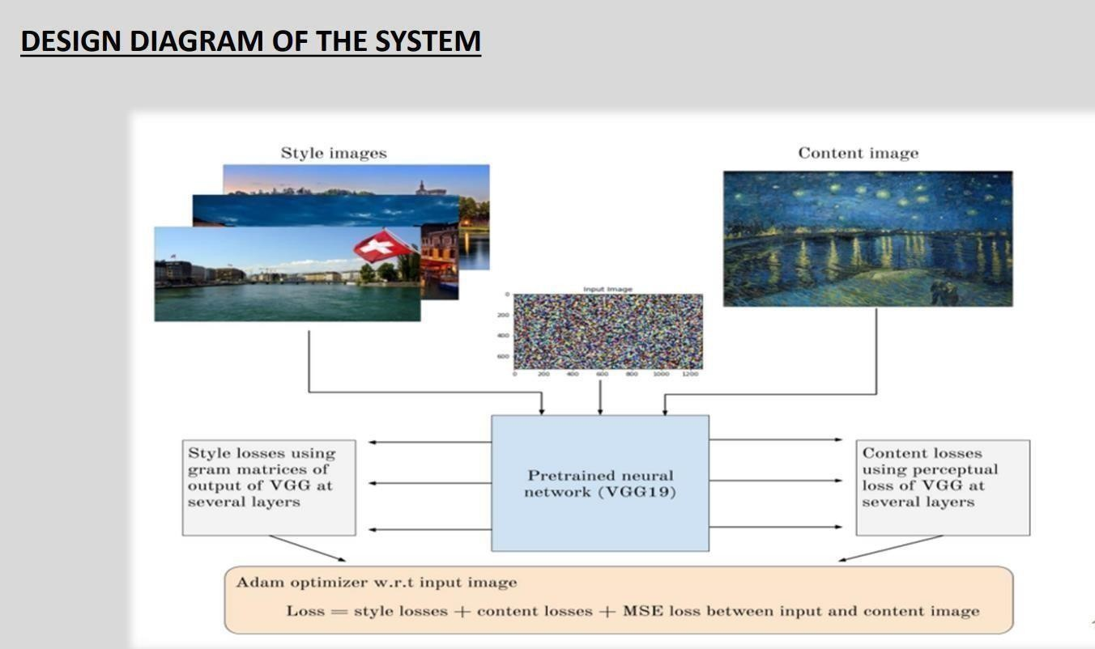

**Fig 3.1:** It represents Design Diagram of the System.

* + 1. **Use case diagram**

Use case diagram at its simplest is a representation of a user’s interaction with the system that shows the relationship between the user and the different use cases in which the user is involved. A use case diagram can identify the different types of users of a system and the different use cases and will often be accompanied.

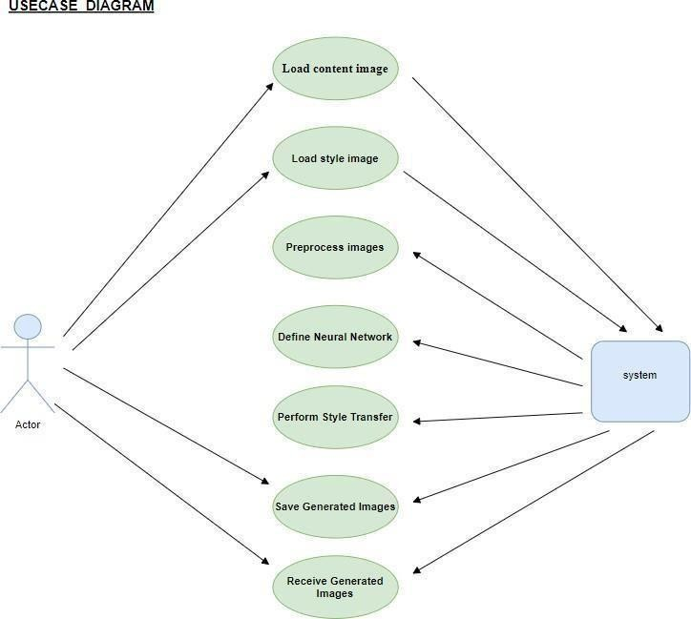

**Fig 3.2:** Representation of use case diagram for two users.

* + 1. **Sequence diagram**

A Sequence diagram Image generation through style transfer initiates with the user providing two input images: a content image, embodying the desired subject matter and structure, and a style image, representing the artistic characteristics to be applied. These images undergo preprocessing, where they are resized, normalized, and converted to a compatible format. Following preprocessing, a pre-trained Convolutional Neural Network (CNN) extracts feature maps from both images, capturing their content and style attributes across various layers. Content representation involves computing the content loss by comparing the feature representations of the generated image and the content image, typically derived from intermediate CNN layers. Similarly, style representation entails computing the style loss,

the style image, often utilizing Gram matrices to capture style information. A regularization term, commonly Total Variation Regularization, is introduced to promote smoothness and spatial coherence in the generated image. Through optimization techniques like gradient descent, the generated image is iteratively updated to minimize the combined loss function, which comprises content, style, and regularization losses.

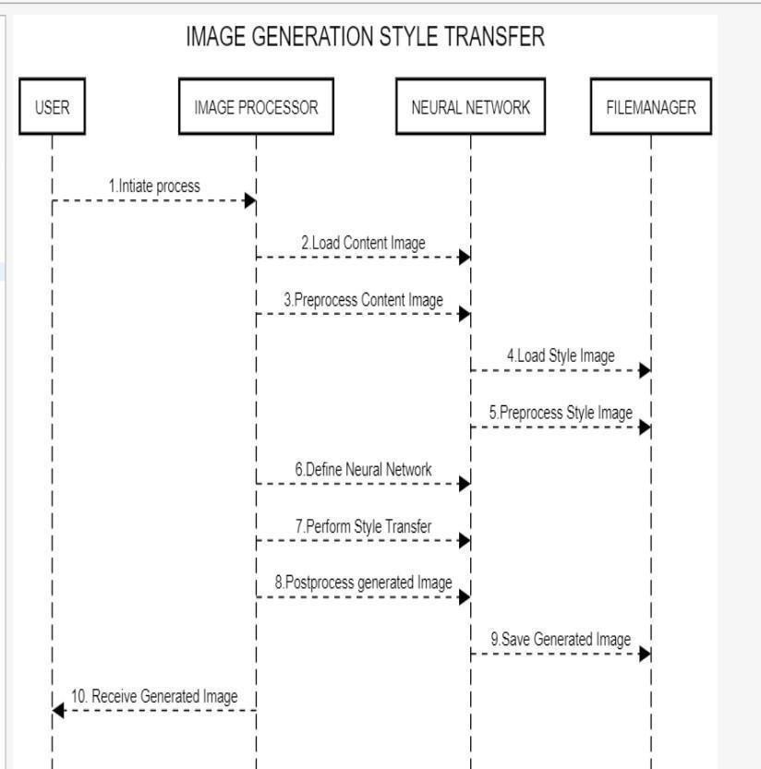

**Fig 3.3:** Representation of sequence diagram.

* 1. **Conceptual Design**

The conceptual design for image generation using style transfer involves a systematic workflow starting with user input, where two images are provided: a content image defining the subject matter and a style image dictating the desired artistic style. These images undergo preprocessing to standardize their format and size. Feature extraction follows, utilizing a pre- trained Convolutional Neural Network (CNN) to capture both low-level and high-level features from the content and style images. Content and style representation steps quantify the content and style features, respectively, using techniques like content loss computation and Gram matrix calculation for style loss. Regularization techniques ensure smoothness and coherence in the generated image. Optimization, driven by algorithms like gradient descent, iteratively updates the generated image to minimize a combined loss function

comprising content, style, and regularization terms. Backpropagation computes gradients to guide the updates, while postprocessing steps ensure the final image adheres to valid ranges. The output is a seamlessly blended image, combining the content of the content image with the style of the style image, achieving the desired fusion of content and style characteristics.

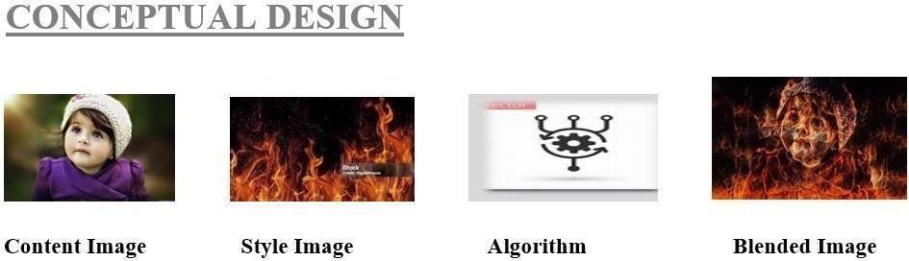

**Fig 3.4:** It represents the Conceptual Design.

* 1. **Logical Design**

The logical design for image generation using style transfer comprises several interconnected modules, each serving a specific function within the overall process. Beginning with the Input Module, user-provided content and style images are received and forwarded to the Preprocessing Module, where standardization tasks such as resizing, normalization, and color space conversion are performed to ensure compatibility for subsequent processing. The Feature Extraction Module utilizes a pre-trained Convolutional Neural Network (CNN) to extract comprehensive feature representations from the input images, capturing both low- level and high-level content and style attributes. Following this, the Content and Style Representation Module computes content and style features from the respective images, employing techniques like content loss computation and Gram matrix calculation for style loss. These features contribute to the Loss Calculation Module, where the total loss function is determined by combining content, style, and regularization losses. The Regularization Module ensures smoothness and coherence in the generated image through techniques like Total Variation Regularization, mitigating noise and distortions. Optimization is then conducted in the Optimization Module, employing algorithms like gradient descent to iteratively update the generated image, minimizing the total loss function. Backpropagation guides this optimization process by computing gradients and updating pixel values accordingly.

Finally, the Postprocessing Module performs final adjustments on the generated image, such

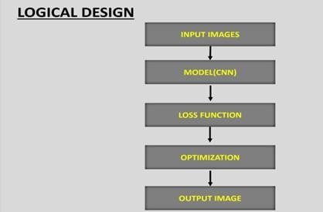as clipping pixel values to maintain validity withina specified range, before delivering the seamlessly blended output to the user.

**Fig 3.5:** It represents the Logical Design of the system.

* 1. **Architectural Design**

Architectural design is a concept that focuses on components or elements of a structure any changes the client wants to make to the design should be communicated to the architect during this phase.

The architecture for generating images using style transfer involves several interconnected stages. Initially, preprocessing steps are applied to the input images, including resizing, normalization, and format conversion. Feature extraction is then performed using a pre- trained Convolutional Neural Network (CNN), which captures both low-level and high-level features from the input images. These features are utilized to represent both content and style aspects of the images. Content representation involves computing a content loss function that measures the difference between features of the generated image and the content image, typically from a middle layer of the CNN. Similarly, style representation entails calculating a style loss function by comparing Gram matrices of features from the generated image and the style image, capturing style information across different layers. Additionally, a regularization term, often Total Variation Regularization, is incorporated to encourage smoothness in the generated image. Optimization techniques like gradient descent are then employed to minimize the combined loss function, updating the generated image iteratively to reduce content, style, and regularization losses.

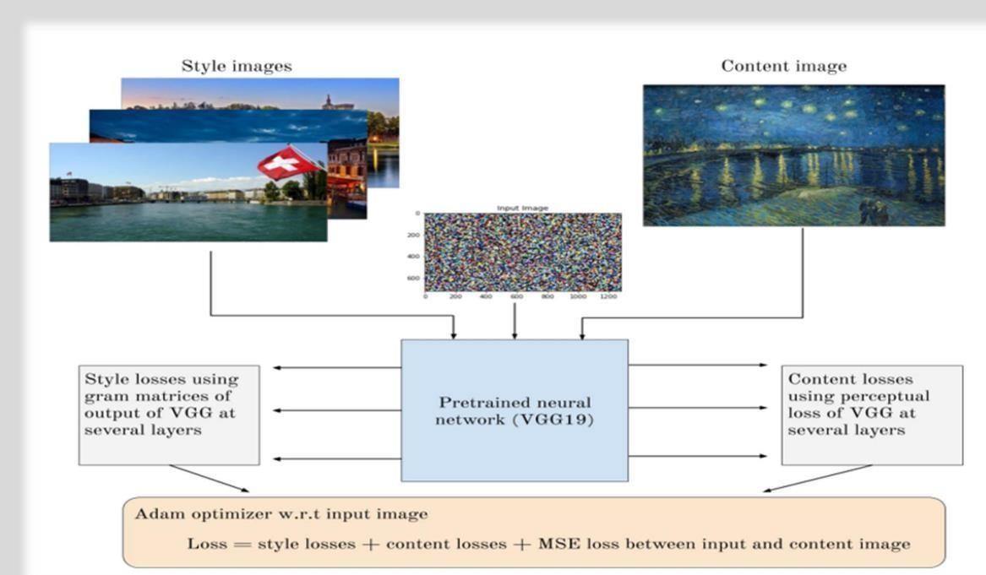

**Fig 3.6:** It represents the Architectural Design.

**3.6. Algorithms Design Algorithm for user:**

**Steps:**

1. Start.
2. Open the image generation application.
3. Upload or select a content image and a style image from your device.
4. If you don't have suitable images, browse or search for images within the application's library.
5. Specify any additional parameters such as style strength, output resolution, or artistic filters.
6. Initiate the style transfer process and wait for the algorithm to generate the stylized image.
7. Preview the stylized image and make any necessary adjustments or refinements.
8. Save the stylized image to your device or share it directly from the application.
9. Optionally, provide feedback or rating for the generated result to improve future iterations.
10. Logout or exit the application.
11. Stop.

**Algorithm for admin:**

Steps:

1. Start.
2. Open the Image Generation Application.
3. Login using valid admin credentials.
4. Access user-submitted content and style images along with any additional details provided during image selection.
5. Store relevant user data for reference or analysis.
6. Initiate style transfer process on user-submitted images if necessary for administrative purposes.
7. View and analyze the generated stylized images or results.
8. Choose from various graphical representations to visualize data or results as needed.
9. Perform any additional data analysis or manipulation required by the administrative tasks.
10. Logout from the admin account.
11. Stop.

**3.7. Database Design**

* In designing the database for an Image Generation Using Style Transfer application, several key entities and relationships need to be considered. The database would typically include tables for users, images, generated results, and possibly administrative data.
* The users table would store information such as user ID, username, password (encrypted), email, and any other relevant user details. This table would also handle user authentication and authorization.
* The images table would store details about the uploaded content and style images, including their file paths or binary data, user ID linking them to their respective users, and any additional metadata such as upload timestamps or image dimensions.
* The results table would contain information about the generated stylized images, including their file paths or binary data, the IDs of the content and style images used, user ID, timestamp of generation, and any relevant parameters or settings applied during the generation process.
* Overall, the database design aims to efficiently store and manage user data, images, generated results, and potentially administrative information, supporting the functionality of the Image Generation Using Style Transfer application while maintaining data integrity and security.

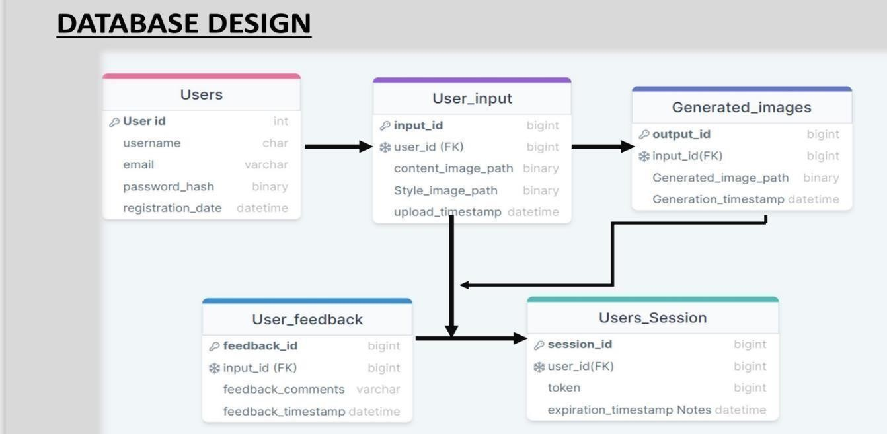

**Fig 3.7:** It represents the Database Design.

**Dataflow diagram:**

* In the dataflow diagram (DFD) for the Image Generation Using Style Transfer application, the system operates at multiple levels, each delineating different functionalities and interactions. At the highest level, the Level 0 DFD outlines the overarching components of the system: the users, admins, and the database. Users interact with the system by uploading images, initiating style transfer, viewing stylized images, providing feedback, and logging out. Meanwhile, admins perform administrative functions such as logging in, accessing user data, viewing results, and logging out. The database serves as the repository for user data, images, and generated results, facilitating data storage and retrieval.
* Optionally, a Level 2 DFD could provide a more detailed perspective on specific processes within the system, such as image upload, style transfer, and admin data management. These processes involve steps like receiving and validating uploaded images, initializing style transfer algorithms, generating stylized images, and managing user data by admins.
* Overall, the DFD offers a structured depiction of the flow of data and operations within the Image Generation Using Style Transfer application, illustrating the interactions between users, admins, and the underlying database.

**Components of a Data flow diagram:**

The different components of it are:

**Process:**

The process was the Generated Stylized Image. Symbol was the Rectangle.

**Description:**

This process transforms input content and style images into a stylized output image using style transfer algorithms.

**Inputs:**

**Content Image**: The original image that serves as the basis for the generated image.

**Style Image**: The image whose artistic style will be applied to the content image.

**Outputs:**

**Stylized Image**: The resulting image that combines the content of the content image with the style of the style image.

**Description of Operation:**

* **Receive Content Image**: Obtain the content image uploaded by the user.
* **Receive Style Image**: Obtain the style image selected by the user.
* **Initiate Style Transfer**: Start the style transfer algorithm using the content and style images as inputs.
* **Generate Stylized Image**: Apply the style transfer algorithm to generate the stylized image.
* **Output Stylized Image**: Provide the generated stylized image as the output of the process.
* This process encapsulates the transformation of input images (content and style) into a visually appealing output image through the style transfer process, facilitating the creation of artistic compositions.

**Data Flow:**

* The data flow of the image generation using style transfer system, various inputs and outputs traverse through different components to facilitate the transformation of content and style images into stylized outputs.
* Users initiate the process by providing content and style images as inputs to the system. These inputs flow into the system through designated interfaces or upload mechanisms. Once received, the content and style images are processed within the system, undergoing the style transfer algorithm, which is responsible for blending the content and style characteristics.
* During this process, data flows between different modules, such as the image processing module, where the style transfer algorithm operates. The algorithm manipulates the pixel values of the content image to reflect the stylistic features extracted from the style image.
* As the style transfer process progresses, intermediate and final outputs are generated. Intermediate outputs may include feature representations extracted from the content and style images, while the final output is the stylized image itself.
* Throughout the data flow, careful management and validation of inputs and outputs ensure the integrity and quality of the generated stylized images, providing users with a seamless and satisfying experience..

**Warehouse:**

* In the context of image generation using style transfer, a warehouse serves as a centralized repository for storing and managing various data related to the system's operation. This warehouse acts as a comprehensive storage solution, housing not only the images uploaded by users but also the generated stylized images, user metadata, system logs, and other relevant information.
* The warehouse efficiently organizes and categorizes data to facilitate easy retrieval and analysis. It employs database management systems to ensure data integrity, security, and scalability. Users' content and style images are securely stored in the warehouse upon upload, along with associated metadata such as timestamps, user IDs, and image properties.
* Furthermore, the warehouse maintains a record of the style transfer process, including parameters used, processing times, and any errors encountered during

image generation. This information enables system administrators to monitor system performance, troubleshoot issues, and optimize processes for better efficiency.

* Overall, the warehouse serves as the backbone of the image generation system, providing a robust infrastructure for data storage, management, and analysis. Its efficient operation ensures the smooth functioning of the system and enhances the user experience by enabling seamless access to images and generated results.

**Terminator:**

* In the context of dataflow diagrams (DFDs), a terminator represents the start or end of a process or system. It signifies the points at which data enters or exits the system, serving as the interface between the system and external entities.
* In the image generation using style transfer system, terminators play a crucial role in delineating the boundaries of the system and indicating the flow of data into and out of the system. At the start of the process, a terminator symbolizes the input of data into the system, such as users uploading content and style images. This input data initiates the image generation process within the system.
* Conversely, at the end of the process, a terminator represents the output of data from the system. This output typically includes the generated stylized images, which are provided to users for viewing or download. Additionally, system logs, error messages, or other relevant information may also be outputted for administrative purposes or system maintenance.
* Overall, terminators in the image generation system serve as entry and exit points for data, delineating the boundaries of the system and facilitating the flow of information between the system and its users. They provide clarity and structure to the dataflow diagram, helping to visualize the interactions between the system and its external environment.

**Data Flow for the User:**

* In the data flow for the user within the image generation using style transfer system, a series of interactions occur between the user and the system, facilitating the input of data, processing, and output of results.
* The user begins by interacting with the system's interface, typically through a web or mobile application. They initiate the data flow by uploading content and style

images from their device to the system. These images serve as the primary inputs for the style transfer process.

* Once the images are uploaded, they flow into the system through designated interfaces, such as file upload mechanisms. The system receives and processes the input images, applying style transfer algorithms to generate stylized outputs.
* During this process, the user may also interact with the system to specify preferences or parameters for the style transfer, such as adjusting the strength of the style or selecting specific artistic filters.
* Throughout the data flow, the system ensures the integrity and security of the user's data, providing a seamless and intuitive experience for uploading images, customizing style transfer settings, and accessing the generated stylized images.

**Data Flow Diagram for admin:**

* In the data flow for the admin within the image generation using style transfer system, several interactions occur between the admin and the system, facilitating administrative tasks, data management, and system oversight.
* The admin initiates the data flow by accessing the system's interface, typically through a dedicated admin portal or dashboard. They authenticate themselves by providing valid credentials, enabling access to administrative functionalities.
* Once authenticated, the admin interacts with the system to perform various tasks, such as viewing user-submitted content and style images, managing generatedresults, and overseeing system operations.
* Once the style transfer is complete, the system provides the admin with access to the generated stylized images and associated data. The admin can review and analyze the results, providing feedback or taking further actions as needed.
* Throughout the data flow, the system ensures the security and integrity of the admin's interactions and data, maintaining strict access controls and encryption protocols to protect sensitive information.
* Overall, the data flow for the admin enables efficient management and oversight of the image generation system, empowering administrators to monitor operations, analyze data, and maintain system integrity.

**3.8 MODULE DESIGN SPECIFICATIONS**

* The User Authentication Module serves to authenticate users during login by verifying their credentials against stored data in the system's database. This module implements robust security measures, including encryption and session management, to ensure secure user access.
* The Style Transfer Module implements style transfer algorithms to generate stylized images from user-provided content and style images. It offers customization options for adjusting style transfer parameters, providing users with flexibility and control over the stylization process.
* To facilitate user interaction with the system, the User Interface Module offers a user-friendly interface with features for image selection, parameter adjustment, and result visualization. It ensures responsiveness and compatibility across different devices and screen sizes, enhancing the user experience.
* The Data Management Module handles the storage and retrieval of user data, images, and generated results. It implements database operations such as Create, Read, Update, Delete (CRUD), while maintaining data integrity, security, and scalability.
* The Notification Module sends notifications to users and administrators for important events or updates. It includes features for email notifications, in-app notifications, and push notifications, with customizable notification settings for usersto manage their preferences.
* These module design specifications collectively outline the functionalities and features of the image generation using style transfer system, ensuring its functionality, usability, security, and performance.

**CHAPTER – 4**

**CODING INPUT & OUTPUT SCREENS**

* 1. **SAMPLE CODING**

The sample coding phase of an application typically involves writing code that implements the design and functionality of the application based on the specifications and requirements gathered during the planning and design phase.

**AIM:** To write a python program for Image Generation Using Style Transfer.

**Main.py**

import streamlit as st

from streamlit_option_menu import option_menu import home, test,editing,premium,feedback, about st.set_page_config(

page_title="STYLE TRANSFER",

)

class MultiApp: def _init_(self):

self.apps = []

def add_app(self, title, func): self.apps.append({

"title": title, "function": func

})

def run():

# app = st.sidebar( with st.sidebar:

app = option_menu( menu_title='STYLE TRANSFER ',

options=['Home','Account','Editing','Premium','Feedback','about'], icons=['house-fill','person-circle','magic','diamond','chat-fill','info-circle-fill'], menu_icon='chat-text-fill',

default_index=1,

styles={

"container": {"padding": "5!important","background-color":'black'},

"icon": {"color": "white", "font-size": "23px"},

"nav-link": {"color":"white","font-size": "20px", "text-align": "left", "margin":"0px", "--hover-color": "blue"},

"nav-link-selected": {"background-color": "#02ab21"},}

)

if app == "Home": home.app()

if app == "Account": test.app()

if app == "Editing": editing.app()

if app == 'Premium': premium.app()

if app == 'Feedback': feedback.app()

if app == 'about': about.app()

run()

**AIM:** To write a python program for Home Page.

**Home.py**

import streamlit as st

from firebase_admin import firestore from PIL import Image

def app():

st.header(' :violet[WELCOME TO THE REALISTIC STYLE TRANSFER] ')

image_path="C:/Users/DELL/PROJECTS/style/sty.jpeg" img=Image.open(image_path)

st.image(img,width=600)

**AIM:** To write a python program for Testing process.

**Test.py**

import streamlit as st import firebase_admin

from firebase_admin import firestore from firebase_admin import credentials from firebase_admin import auth

cred = credentials.Certificate("pondering-5ff7c-c033cfade319.json") firebase_admin.initialize_app(cred)

def app():

st.title('Welcome to :violet[STYLISH WORLD] :sunglasses:') if 'username' not in st.session_state:

st.session_state.username = ''

if 'useremail' not in st.session_state: st.session_state.useremail = ''

def f(): try:

user = auth.get_user_by_email(email) print(user.uid) st.session_state.username = user.uid st.session_state.useremail = user.email global Usernm

Usernm=(user.uid) st.session_state.signedout = True st.session_state.signout = True except:

st.warning('Login Failed') def t():

st.session_state.signout = False st.session_state.signedout = False st.session_state.username = ''

if "signedout" not in st.session_state:

st.session_state["signedout"] = False if 'signout' not in st.session_state:

st.session_state['signout'] = False if not st.session_state["signedout"]:

choice = st.selectbox('Login/Signup',['Login','Sign up']) email = st.text_input('Email Address')

password = st.text_input('Password',type='password') if choice == 'Sign up':

username = st.text_input("Enter your unique username") if st.button('Create my account'):

user = auth.create_user(email=email, password=password, uid=username) st.success('Account created successfully!')

st.markdown('Please Login using your email and password') st.balloons()

else:

st.button('Login', on_click=f) if st.session_state.signout:

st.text('Name '+st.session_state.username) st.text('Email id: '+st.session_state.useremail) st.button('Sign out', on_click=t)

def ap(): st.write('Posts')

**AIM:** To write a python program for Editing process.

**Editing.py**

import streamlit as st import os

def app():

st.title("Style Transfer Project") # Upload content image

content_image = st.file_uploader("upload content image", type=["jpg", "jpeg", "png"]) style_images = st.file_uploader("Upload style image", type=["jpg", "jpeg", "png"],

accept_multiple_files=True)

# Upload style images st.write("\n\n")

st.button("SUBMIT")

if content_image is not None and style_images is not None: # Save content image to a temporary location content_temp_location = "temp_content_image.png" with open(content_temp_location, "wb") as f:

f.write(content_image.read())

st.image(content_temp_location, caption="Content Image", use_column_width=True) st.write("")

# Save style images to temporary locations style_temp_locations = []

for i, style_image in enumerate(style_images): style_temp_location = f"temp_style_image_{i}.png" with open(style_temp_location, "wb") as f:

f.write(style_image.read()) style_temp_locations.append(style_temp_location) # Display style images

st.image(style_temp_location, caption=f"Style Image {i+1}", use_column_width=True)

st.write("")

import tensorflow_hub as hub import tensorflow as tf

from matplotlib import pyplot as plt import numpy as np

import cv2

model = hub.load('https://tfhub.dev/google/magenta/arbitrary-image-stylization-v1- 256/2')

def load_image(img_path):

img = tf.io.read_file(img_path)

img = tf.image.decode_image(img, channels=3)

img = tf.image.convert_image_dtype(img, tf.float32) img = img[tf.newaxis, :]

return img

content_image = load_image(content_temp_location) style_image = load_image(style_temp_location)

stylized_image = model(tf.constant(content_image), tf.constant(style_image))[0] st.image(np.squeeze(stylized_image),width=600)

st.write("Performing style transfer...")

# You can perform style transfer using the content and style images here # Optional: Remove temporary files after processing

os.remove(content_temp_location)

for style_temp_location in style_temp_locations: os.remove(style_temp_location)

if _name_ == "_main_": main()

**AIM:** To write a python program for Premium.

**Premium.py** import streamlit as st from PIL import Image def app():

image_path = "C:/Users/DELL/PROJECTS/style/price.jpg" image = Image.open(image_path)

st.image(image, caption='Your Image Caption', use_column_width=True) if _name_ == "_main_":

main()

**AIM:** To write a python program for Feedback.

**Feedback.py** import streamlit as st def app():

txt=st.text_area(

label="YOUR FEEDBACK",height=300,max_chars=100,placeholder="write here"

)

st.write(txt) st.button("SUBMIT")

if _name_ == "_main_": main()

**AIM:** To write a python program for to describe the project.

**About.py**

import streamlit as st def app():

st.write

('Our project leverages the captivating technique of style transfer in the domain of computer vision and image processing. This innovative approach allows for the transformation of the visual appearance of an image by merging its content with the artistic characteristics of another. The process is facilitated through deep neural networks, particularly convolutional neural networks (CNNs), which meticulously extract and blend content and style information separately. The resulting output preserves the content features of the original image while incorporating the stylistic elements, including color schemes and textures, from a reference image. Style transfer plays a pivotal role in my project, finding applications in artistic expression, creative content generation, and enhancing visual aesthetics in multimedia projects. Its versatility and ability to seamlessly merge content and style, reminiscent of renowned art movements or artists, make it a compelling and intriguing tool for visual innovation.')

st.markdown('Created by: [KITS STUDENTS]') st.markdown('Contact via mail: [[gnaneshgnata@gmail.com]](mailto:gnaneshgnata@gmail.com)')

**AIM:** To write a python program for the User model.

**User Model.python** import numpy as np import tensorflow as tf

import tensorflow_hub as hub from PIL import Image import os

class User:

def _init_(self, username, password): self.username = username self.password = password self.style_image_path = None

def authenticate(self, password): return self.password == password

def set_style_image(self, image_path): self.style_image_path = image_path

def generate_stylized_image(self, content_image_path): if not self.style_image_path:

raise ValueError("Style image not set") # Load images

content_image = self._load_image(content_image_path) style_image = self._load_image(self.style_image_path) # Apply style transfer

stylized_image = self._apply_style_transfer(content_image, style_image) return stylized_image

def _load_image(self, image_path): img = tf.io.read_file(image_path)

img = tf.image.decode_image(img, channels=3)

img = tf.image.convert_image_dtype(img, tf.float32) img = img[tf.newaxis, :]

return img

def _apply_style_transfer(self, content_image, style_image):

model = hub.load('https://tfhub.dev/google/magenta/arbitrary-image-stylization-v1- 256/2')

stylized_image = model(tf.constant(content_image), tf.constant(style_image))[0] return stylized_image.numpy()

# Example usage

if _name_ == "_main_": # Create a user

user = User("example_user", "password123")

# Authenticate user

if user.authenticate("password123"): print("User authenticated successfully.")

else:

print("Invalid credentials.") # Set style image

user.set_style_image("style_image.jpg") # Generate stylized image

content_image_path = "content_image.jpg"

stylized_image = user.generate_stylized_image(content_image_path) # Save stylized image

stylized_image = np.clip(stylized_image * 255.0, 0, 255).astype(np.uint8) stylized_image = Image.fromarray(stylized_image[0]) stylized_image.save("stylized_image.jpg")

print("Stylized image saved successfully.")

**AIM:** To write a python program for the Data Model.

**Data Model.python**

class Image:

def _init_(self, filename, width, height): self.filename = filename

self.width = width self.height = height def get_filename(self):

return self.filename def get_dimensions(self):

return self.width, self.height class Style:

def _init_(self, filename): self.filename = filename

def get_filename(self): return self.filename

class StyleTransferModel: def _init_(self, model_url):

self.model_url = model_url def load_model(self):

# Load the style transfer model

# Example code to load the model would go here print("Model loaded from:", self.model_url)

def transfer_style(self, content_image, style_image): # Apply style transfer using the loaded model

# Example code for style transfer would go here print("Style transfer applied successfully")

# Example usage:

if _name_ == "_main_":

# Create instances of content image, style image, and style transfer model content_image = Image("content.jpg", 800, 600)

style_image = Style("style.jpg")

style_transfer_model =

StyleTransferModel("https://example.com/style_transfer_model") # Load the style transfer model style_transfer_model.load_model()

# Perform style transfer style_transfer_model.transfer_style(content_image, style_image)

**AIM:** To write a python program for Admin Login Activity.

**Admin login Activity.python**

import getpass class Admin:

def _init_(self, username, password): self.username = username self.password = password

def load_admin_credentials(filename): admins = []

with open(filename, 'r') as file:

for line in file:

username, password = line.strip().split(',') admins.append(Admin(username, password))

return admins

def admin_login(admins):

username = input("Enter admin username: ") password = getpass.getpass("Enter admin password: ") for admin in admins:

if admin.username == username and admin.password == password: print("Admin login successful.")

return True

print("Invalid admin credentials.") return False

def main():

admins = load_admin_credentials("admin_credentials.txt")

if admin_login(admins):

# Perform image generation tasks here print("Welcome, admin!")

# Call style transfer functions or other admin functionalities if _name_ == "_main_":

main()

**AIM:** To write a python program for Register Activity.

**Register Activity.python**

class User:

def _init_(self, username, password): self.username = username self.password = password

def load_user_credentials(filename): users = []

try:

with open(filename, 'r') as file:

for line in file:

username, password = line.strip().split(',') users.append(User(username, password))

except FileNotFoundError:

# If the file doesn't exist, return an empty list of users pass

return users

def register_user(users, filename): username = input("Enter username: ") # Check if the username already exists for user in users:

if user.username == username:

print("Username already exists. Please choose a different username.") return False

password = input("Enter password: ") confirm_password = input("Confirm password: ") if password != confirm_password:

print("Passwords do not match. Please try again.") return False

# Write the new user's credentials to the file with open(filename, 'a') as file:

file.write(f"{username},{password}\n") print("User registered successfully.") return True

def main():

user_credentials_file = "user_credentials.txt"

users = load_user_credentials(user_credentials_file) register_user(users, user_credentials_file)

if _name_ == "_main_": main()

* 1. **OUTPUT SCREENS**

Output screens in project documentation refer to the visual representations of the user interface of a software application or system. These screens are typically included in the project documentation to help stakeholders understand the functionality and design of the application or system.

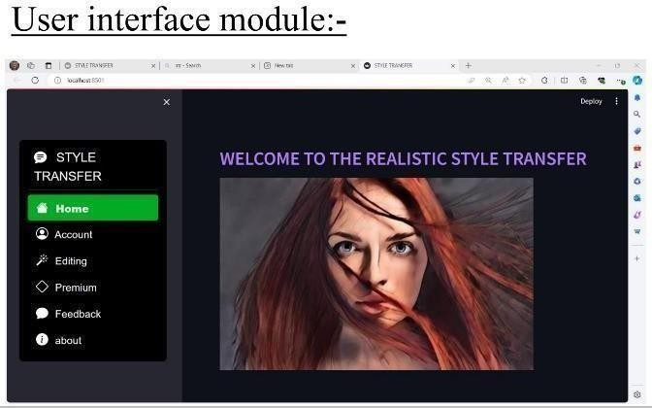

**Screenshot 1:** It represents the UI Interface module.

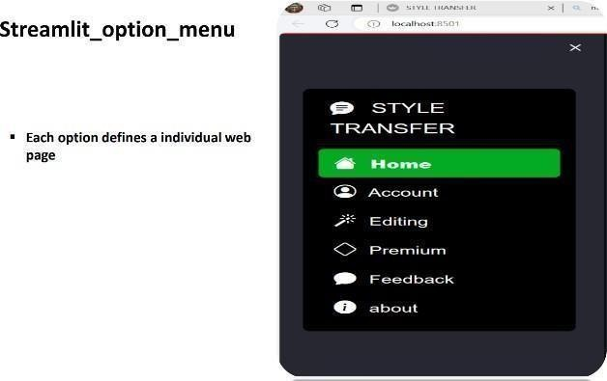

**Screenshot 2:** It represents Streamlit Option Men

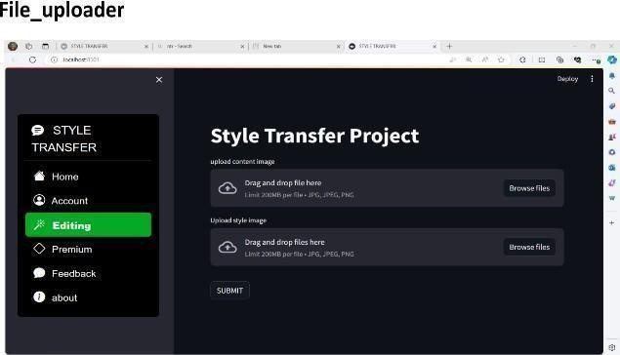

**Screenshot 3:** It represents the File Uploader process.

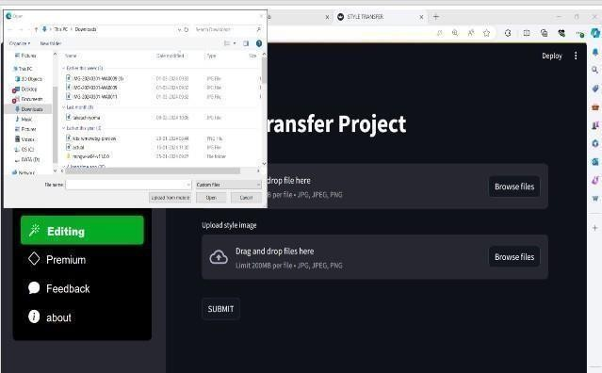

**Screenshot 4:** It represents the content_temp_location.

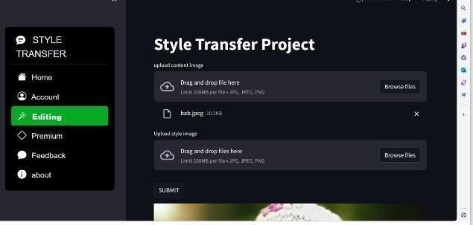

**Screenshot 5:** It represents the Load_image process.

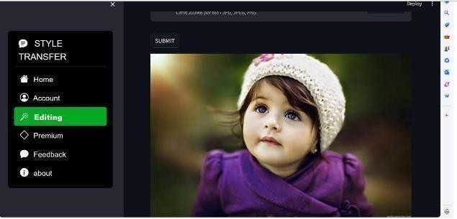

**Screenshot 6:** It represents the Image process.

**Style image processing module:**

* The Style image Processing module handles the style image where the user can upload the image from the local browser .

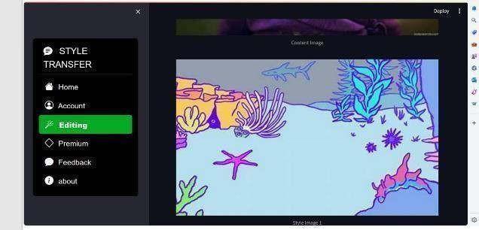

**Screenshot 7:** It Represents the STYLE process.

**Then the output is:**

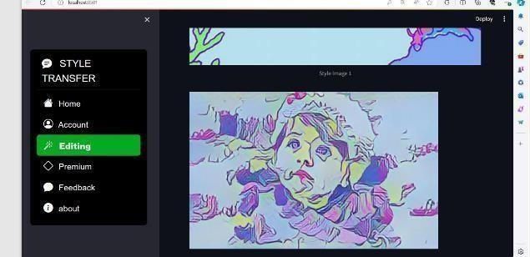

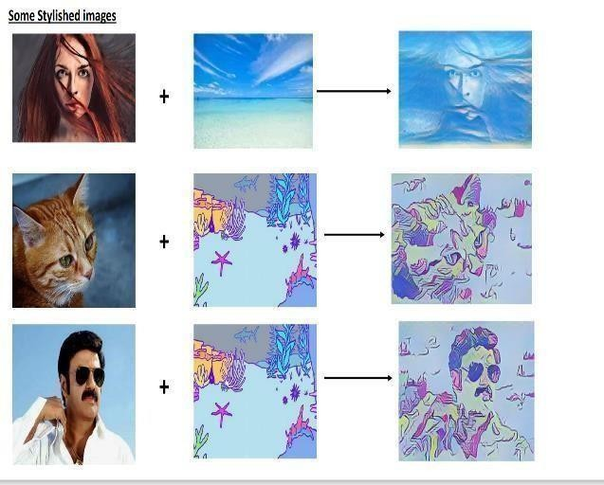

**Some Stylished Images**

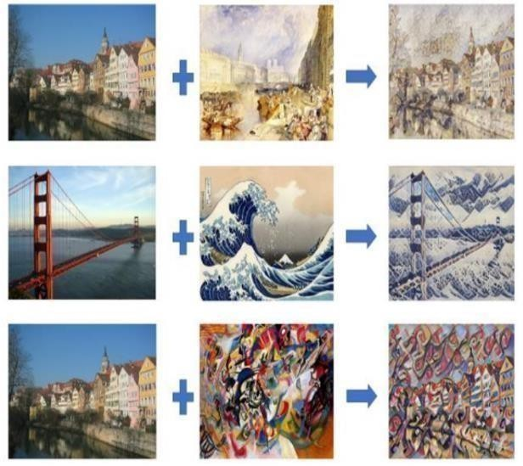

**4.3. SCREEN REPORTS**

A "screen report" is a type of documentation that describes the user interface of a software application or system. It typically includes a visual representation of each screen or page in the user interface, along with a description of the functionality and features of each screen. A screen report is often used as a reference guide for developers, and testers working on the project. It can also be used to communicate the design and functionality of the user interface.



**Screenshot 8:** It represents the Screen Reports.

The file is successfully build.

**CHAPTER – 5 TESTING**

* 1. **Introduction to Testing**

The purpose of testing is to discover errors. Testing is the process of trying to discover every conceivable fault or weakness in a work product. It provides a way to check the functionality of components, sub-assemblies, assemblies and or a finished product. It is the process of exercising software with the intent of ensuring that the Software system meets its requirements and user expectations and does not fail in an unacceptable manner. There are various types of tests. Each test type addresses a specific testing requirement.

**Basic levels of testing**

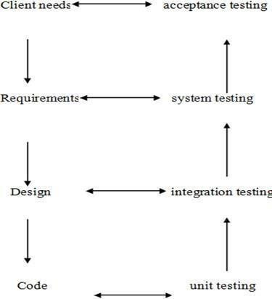

Testing levels

* 1. **Types of Testing**

**Unit testing**:

Unit testing involves the design of test cases that validate that the internal program logic is functioning properly, and that program inputs produce valid outputs. All decision branches and internal code flow should be validated. It is the testing of individual software units of the application. It is done after the completion of an individual unit before integration. This is a structural testing, that relies on knowledge of its construction and is invasive. Unit tests perform basic tests at component level and test a specific business

process, application, and/or system configuration. Unit tests ensure that each unique path of a business process performs accurately to the documented specifications and contains clearly defined inputs and expected results.

**Integration testing:**

Integration tests are designed to test integrated software components to determine if they actually run as one program. Testing is event driven and is more concerned with the basic outcome of screens or fields. Integration tests demonstrate that although the components were individually satisfied, as shown by successfully unit testing, the combination of components is correct and consistent. Integration testing is specifically aimed at exposing the problems that arise from the combination of components.

**Functional testing:**

Functional tests provide systematic demonstrations that functions tested are available as specified by the business and technical requirements, system documentation, and user manuals.

Functional testing is centered on the following items:

Valid Input : Identified classes of valid input must be accepted. Invalid Input : Identified classes of invalid input must be rejected. Functions : Identified functions must be exercised.

Output : Identified classes of application outputs must be exercised. Systems/Procedures: Interfacing systems or procedures must be invoked.

Organization and preparation of functional tests is focused on requirements, key functions, or special test cases. In addition, systematic coverage pertaining to identify Business process flows; data fields, predefined processes, and successive processes must be considered for testing. Before functional testing is complete, additional tests are identified and the effective value of current tests is determined.

**System testing:**

System testing ensures that the entire integrated software system meets requirements. It tests a configuration to ensure known and predictable results. An example of system testing is the configuration oriented system integration test. System testing is based on process descriptions and flows, emphasizing pre-driven process links and integration points.

**White-box testing:**

White Box Testing is a test in which the software tester has knowledge of the inner workings, structure and language of the software, or at least its purpose. It is purpose. It is used to test areas that cannot be reached from a black box level.

**Black-box testing:**

Black Box Testing is testing the software without any knowledge of the inner workings, structure or language of the module being tested. Black box tests, as most other kinds of tests, must be written from a definitive source document, such as specification or requirements document, such as specification or requirements document. It is a test in which the software under test is treated as a black box. You cannot “see” it. The test provides inputs and responds to outputs without considering how the software works.

**Unit Testing:**

Unit testing is usually conducted as part of a combined code and unit test phase of the software lifecycle, although it is not uncommon for coding and unit testing to be conducted as two distinct phases.

**Test strategy and approach:**

Field testing will be performed manually and functional tests will be written in detail.

**Test objectives:**

* All field entries must work properly.
* Pages must be activated from the identified link.
* The entry screen, messages and responses must not be delayed.

**Features to be tested:**

* Verify that the entries are of the correct format
* No duplicate entries should be allowed
* All links should take the user to the correct page.

**Integration Testing:**

Software integration testing is the incremental integration testing of two or more integrated software components on a single platform to produce failures caused by interface defects. The task of the integration test is to check that components or software applications,

e.g. components in a software system or – one step up – software applications at the company level – interact without error.

**Acceptance Testing:**

User Acceptance Testing is a critical phase of any project and requires significant participation by the end user. It also ensures that the system meets the functional requirements.

* 1. **Test cases and Test Reports**

**Test case 1: Test case on login module of user data.**

This test case is used to check the working of the login module of the user.

|  |  |
| --- | --- |
| T**est Case1:** Check customer login with valid and invalid data. | **Priority:** High |
| **Test Objective:** To check if the system is responding to valid data or not. | |
| **Test Description:** The user must enter into his interface. Login rejected, An error should be displayed. | |
| **Test Requirements Verified:** Yes | |
| **Test Environment:** Mobile | |
| **Test Setup:** The server should be in running state and all the required technologies should be installed and the setup of the environment should be completed. | |
| **Actions:** Provide the required details like username and password. | **Expected result:** Login is done successfully and the user enters into his interface. |
| **Pass:** Yes  **Conditions pass:** Yes  **Fail:** No | |
| **Problems or Issues:** None | |
| **Note:** Successfully Processed | |

**Test case 2**

Table 1: Test case on login module of user credentials.

**Test case on login module of admin data.**

This test case used to check the working of the admin's login module by giving valid data.

|  |  |
| --- | --- |
| **Test Case 2:** .Check admin login with valid data. | **Priority:** High |
| **Test Objective:** To check the admin login module if it responds correctly or not. | |
| **Test Description:** The admin must enter into his interface. | |
| **Test Requirements Verified:** Yes | |
| **Test Environment:** Mobile. | |
| **Test Setup:** The server should be in running state and all the required technologies should be installed and the setup of the environment should be completed. | |
| **Actions:** Provide the required details like username and password correctly. | **Expected result:** Admin enters into his interface. |
| **Pass:** Yes **Conditions pass:** Yes **Fail:** No | |
| **Problems or Issues:** None | |
| **Note:** Successfully Processed | |

Table 2: Test case on login module of admin data

**Test case 3**

**Test case on user registration module.**

This test case is used to check if the registration process of a user is done correctly or not , Whether the details are added into the database or not.

|  |  |
| --- | --- |
| **Test Case 3:** .Check user’s registration module. | **Priority:** Low |
| **Test Objective:** To check if the user’s data is being added to the database or not. | |
| **Test Description:** The user can successfully registered into the site. | |
| **Test Requirements Verified:** Yes | |
| **Test Environment:** Mobile. | |
| **Test Setup:** The server should be in running state and all the required technologies should be installed and the setup of environment should be completed. | |
| **Actions:** Provide all the details asked and click on submit. | **Expected result:** Successfully registered. |
| **Pass:** Yes  **Conditions pass:** Yes  **Fail:** No | |
| **Problems or Issues:** None | |
| **Note:** Successfully Processed | |

Table 3: Test case on user registration module

**Test case 4**

**Test case on functionality of search module.**

This test case is used to verify the analysis module that is present in the user interface.

|  |  |
| --- | --- |
| T**est Case 4:** Check the search analysis module. | **Priority:** High |
| **Test Objective:** To search the data provided through database or not. | |
| **Test Description:** The data to be searched in the information of admin’s interface. | |
| **Test Requirements Verified:** Yes | |
| **Test Environment:** Mobile. | |
| **Test Setup:** The server should be in running state and all the required technologies should be installed and the setup of environment should be completed. | |
| **Actions:** Enter the location and click submit. | **Expected result:** The data is searched at the required location. |
| **Pass:** Yes  **Conditions pass:** Yes  **Fail:** No | |
| **Problems or Issues:** None | |
| **Note:** Successfully Processed | |

Table 4: Test case on functionality of search module.

**Test case 5**

**Test case on the functionality to add data at admin interface.**

|  |  |
| --- | --- |
| T**est Case 5:** Check the functionality of data added at admin interface. | **Priority:** High |
| **Test Objective:** To check if the data is added to the database or not. | |
| **Test Description:** The data added in the database of admin’s interface. | |
| **Test Requirements Verified:** Yes | |
| **Test Environment:** Mobile. | |
| **Test Setup:** The server should be in running state and all the required technologies should be installed and the setup of environment should be completed. | |
| **Actions:** Store all required details. | **Expected result:** Now the data is stored in admin interface. |
| **Pass:** Yes  **Conditions pass:** Yes  **Fail:** No | |
| **Problems or Issues:** None | |
| **Note:** Successfully Processed | |

Table 5: Test case on the functionality to add data at admin interface.

**Test case:6**

**Test case on the location analysis module**

|  |  |
| --- | --- |
| T**est Case 6:** Check the location analysis module. | **Priority:** High |
| **Test Objective:** To check if the data provided through location analysis module to database or not. | |
| **Test Description:** The data provided is displayed in the user information of admin’s interface. | |
| **Test Requirements Verified:** Yes | |
| **Test Environment:** Mobile. | |
| **Test Setup:** The server should be in running state and all the required technologies should be installed and the setup of environment should be completed. | |
| **Actions:** Provide all the required details and click submit. | **Expected result:** Now the data is displayed at the user information module of admin. |
| **Pass:** Yes  **Conditions pass:** Yes  **Fail:** No | |
| **Problems or Issues:** None | |
| **Note:** Successfully Processed | |

Table 6: Test case on the location analysis module

**Test case 7**

**Test case on output module**

|  |  |
| --- | --- |
| T**est Case 7:** Check the functionality of output module. | **Priority:** High |
| **Test Objective:** To check if the data displayed through the interface or not. | |
| **Test Description:** The data displayed in the form of pie chart. | |
| **Test Requirements Verified:** Yes | |
| **Test Environment:** Mobile. | |
| **Test Setup:** The server should be in running state and all the required technologies should be installed and the setup of environment should be completed. | |
| **Actions:** Enter the required location and submit. | **Expected result:** Now the data is displayed in the form of pie chart. |
| **Pass:** Yes  **Conditions pass:** Yes  **Fail:** No | |
| **Problems or Issues:** None | |
| **Note:** Successfully Processed | |

Table 7: Test case on output module

**CHAPTER – 6 IMPLEMENTATION**

* 1. **IMPLEMENTATION INTRODUCTION**

Implementation is the carrying out, execution, or practice of a plan, a method, or any design, idea, model, specification, standard or policy for doing something. As such, implementation is the action that must follow any preliminary thinking in order for something to actually happen. Many preparations are involved before and during the implementation of the proposed system.

* 1. **IMPLEMENTATION PROCEDURE & STEPS**
     1. **Implementation Steps**

The following are to be followed during the project:

* + - * Ensure that the system has a stable internet connection to access the required resources for style transfer.
      * Access the style transfer website or application where you can upload images and apply different styles.
      * If the website or application requires user authentication, choose the "User Login" option and provide your credentials to log in.
      * If you're new to the style transfer platform, select the "Sign Up" or "Create Account" option on the homepage.
      * Follow the prompts to create a new account, providing necessary information such as username, password, and email.
      * After logging in or accessing the platform, upload the images you want to use for style transfer. Typically, you'll upload at least two images: one as the content image and the other as the style image.
      * Select the style transfer option or tool provided on the website or application interface. This could be a button, dropdown menu, or tab labeled "Style Transfer" or something similar.
      * Choose the style you want to apply to your content image. This can be done by uploading another image as the style reference or selecting from pre-defined style options provided by the platform.
      * Some style transfer applications provide options to adjust parameters such as style intensity, blending mode, etc. Adjust these parameters according to your preference if available.
      * Once you've uploaded your content image, selected the style, and adjusted parameters (if applicable), initiate the style transfer process by clicking on the "Apply" or "Transfer" button.
      * After the style transfer process is complete, the platform will generate a new image that combines the content of your original image with the style you selected. View and analyze the generated image.
      * If satisfied with the generated image, save or download it to your device. Most platforms provide options to save the image directly or download it to your computer.
      * If you logged in as a user, you can choose to logout from your account to maintain security and privacy.
    1. **IMPLEMENTATION PROCEDURE**

**Set Up Environment:**

* + - * Ensure you have a stable internet connection.
      * Prepare the device (computer or smartphone) with a web browser or install the necessary style transfer application.
      * Configure a development environment tailored to the project's requirements. This may include selecting an integrated development environment (IDE), text editor, or command-line interface (CLI) tools optimized for the programming languages and technologies used in the project.
      * Dependency Management: Set up a dependency management system to handle external libraries, frameworks, and packages used in the project. Depending on the programming language, tools like npm, pip, Maven, or Composer can manage dependencies and ensure consistent environments across development, testing, and production.
      * Consider using virtualization or containerization technologies such as Docker to create isolated and reproducible environments for development and testing. Docker

containers provide a lightweight and portable solution for packaging applications and their dependencies.

* + - * Define and manage environment variables to configure application settings, credentials, and sensitive information. Use environment-specific configuration files or tools like dotenv to load environment variables dynamically based on the execution environment.

**Access Style Transfer Platform:**

* + - * Open the web browser and navigate to the preferred style transfer website or launch the style transfer application.
      * Determine whether you'll be accessing the platform through a website or a dedicated application on your device.
      * The platform by searching online or through app stores. Look for platforms that offer style transfer functionalities.
      * Some platforms mayrequire user registration or login to access their services. Create an account or sign in if necessary.
      * Familiarize yourself with the platform's interface. Explore options for uploading images, selecting styles, and adjusting parameters.

**User Authentication (Optional):**

* + - * If the platform requires user authentication, sign in with your existing credentials or create a new account.
      * Optional user authentication provides users with the flexibility to choose whether or not they want to create an account and log in to access certain features or functionalities of the platform.
      * Users can access basic features of the platform without the need to create an account or provide personal information. This allows for anonymous browsing and usage of the platform.
      * Optional user authentication lowers the barrier to entry for users who may be hesitant to create an account or share personal information. It allows them to explore the platform without committing to registration.

**Upload Images:**

* + - * Locate the option to upload images on the platform.
      * Select the image you want to use as the content image and upload it.
      * Similarly, upload the image you want to use as the style reference.
      * The upload speed can vary depending on factors such as your internet connection speed and the size of the image files.
      * If you're experiencing slow upload speeds, consider optimizing your images for web or reducing their file size before uploading.
      * Be mindful of the privacy and security implications of uploading images to a third- party platform. Ensure that you're comfortable with the platform's terms of service and privacy policy regarding the handling of your uploaded images and personal data.

**Select Style Transfer Option:**

* + - * Find the style transfer feature or tool on the platform's interface.
      * Click on the style transfer option to proceed with the process.
      * Some platforms offer a visual representation of the style transfer option, such as thumbnails or previews of different styles. This can help users quickly browse and select their preferred style.
      * Explore the platform's style library to see the range of artistic styles available for transfer. Look for platforms that offer a diverse selection of styles to choose from, including various artistic movements, painting styles, and photographic effects.
      * Consider whether the platform offers customization options for style transfer. Some platforms allow users to adjust parameters such as style intensity, color balance, or brush size to fine-tune the style transfer effect according to their preferences.

**Choose Style:**

* + - * Depending on the platform, you can either upload another image as the style reference or choose from pre-defined style options.
      * If selecting from pre-defined styles, browse through the available options and pick the one that suits your preference.
      * Look for platforms that provide descriptions or explanations of each style option. This could include information about the artistic movement, inspiration, or characteristics of the style, helping users understand its aesthetic qualities.
      * Some platforms provide preview thumbnails or small samples of each style option. These previews give users a quick glimpse of what the style will look like when applied to their image, aiding in the decision-making process.

**Adjust Parameters (Optional):**

* + - * Some platforms offer additional parameters to adjust, such as style intensity, blending mode, or image resolution.
      * Modifythese parameters according to your preference, if available.
      * Look for platforms that offer control over the intensity or strength of the style transfer effect. Adjusting the intensity allows users to fine-tune the balance between the content image and the applied style, achieving the desired aesthetic.
      * Some platforms may offer different blending modes for combining the content image with the style. Experimenting with blending modes such as overlay, multiply, or screen can produce unique effects and enhance the overall composition.
      * Consider platforms that provide options to adjust color balance or hue/saturation levels during style transfer. These adjustments can help harmonize the colors between the content image and the style, resulting in a more cohesive and visually pleasing outcome.
      * For platforms that offer brush-based editing tools, control over brush size and opacity can be essential for precise adjustments. Users can selectively apply or remove the style transfer effect to specific areas of the image, achieving a customized look.

**Initiate Style Transfer Process:**

* + - * Once you've selected the content image, style reference, and adjusted parameters (if applicable), initiate the style transfer process.
      * Click on the "Apply" or "Transfer" button to start the style transfer algorithm.
      * Before initiating the style transfer process, some platforms may display a confirmation prompt or dialog box to ensure that users are ready to proceed. This helps prevent accidental initiation of the process and allows users to double-check their settings.
      * Look for platforms that provide progress indicators or status bars to track the status of the style transfer process. Progress indicators inform users about the estimated time remaining for completion and reassure them that the process is underway.
      * In case users need to interrupt the style transfer process for any reason, platforms that offer pause and resume functionality can be beneficial. This allows users to pause the process temporarily and resume it later without losing progress.
      * Platforms should provide users with the option to cancel the style transfer process if they change their mind or encounter unexpected issues. A cancel button or option ensures that users have control over the process and can abort it if necessary.
      * In the event of errors or interruptions during the style transfer process, platforms should provide informative error messages or prompts to guide users on troubleshooting steps. Clear error messages help users understand the issue and take appropriate action to resolve it.
      * Consider platforms that offer optimization options to enhance the efficiency and performance of the style transfer process. Optimization techniques such as parallel processing, GPU acceleration, or algorithmic improvements can significantly reduce processing time and resource usage.
      * Platforms that provide dynamic updates to progress indicators ensure that users receive real-time feedback as the style transfer process progresses. Dynamic updates keep users informed and engaged throughout the process.

**Monitor Progress:**

* + - * While the style transfer process is ongoing, monitor the progress bar or any indicators provided by the platform to track the completion status.
      * Before initiating the style transfer process, some platforms may display a confirmation prompt or dialog box to ensure that users are ready to proceed. This helps prevent accidental initiation of the process and allows users to double-check their settings.
      * If you're working with multiple images or styles, consider platforms that offer batch processing capabilities. Batch processing allows users to apply the same style to multiple images simultaneously, saving time and streamlining the workflow.
      * In the event of errors or interruptions during the style transfer process, platforms should provide informative error messages or prompts to guide users on troubleshooting steps. Clear error messages help users understand the issue and take appropriate action to resolve it.

**Review Generated Image:**

* + - * After the style transfer process is complete, the platform will generate a new image combining the content of the original image with the selected style.
      * Review the generated image to ensure it meets your expectations.
      * Some platforms offer a comparison view that allows users to compare the generated image side by side with the original content image. This enables users to evaluate the style transfer effect and assess how it has transformed the original image.
      * Platforms should offer convenient options for downloading the generated image in various formats and resolutions. Users may require different file formats for different purposes, such as web publishing, printing, or further editing.
      * Look for platforms that provide built-in sharing options to easily share the generated image on social media platforms, via email, or through direct links. This allows users to showcase their creations and gather feedback from others.

**Save or Download Image:**

* + - * If satisfied with the generated image, use the platform's options to save or download the image to your device.
      * Follow the prompts to save the image in your preferred format and location.
      * Platforms should offer a variety of file format options for saving or downloading the generated image. Common formats include JPEG, PNG, and TIFF. Providing multiple format options ensures compatibility with different software and devices.
      * Consider platforms that allow users to specify the resolution or image quality settings when saving or downloading the image. This allows users to control the file size and image clarity based on their intended use, such as printing or online sharing.
      * Some platforms provide compression options for optimizing file size without significantly compromising image quality. Users can choose between different compression levels to balance file size and image fidelity.
      * Platforms should preserve metadata such as EXIF data when saving or downloading the image. This includes information about the camera settings, date/time of capture, and location, which can be useful for reference and archival purposes.
      * If users have generated multiple images or versions of the same image, platforms may offer batch download options to download all images at once. This saves time and streamlines the download process, especially for users working with large batches of images.

**Logout (Optional):**

* + - * If you logged in with a user account, consider logging out to secure your account and maintain privacy.
      * Platforms should implement session management mechanisms to automatically log users out after a period of inactivity. This helps prevent unauthorized access if the user forgets to log out manually.
      * Upon logout, platforms should clear session tokens, cookies, and other authentication credentials from the user's device to ensure that their account remains secure. This helps prevent unauthorized access to the account from the same device.
      * Consider platforms that offer the option to log out from all devices associated with the user's account. This is especially useful in case the user suspects unauthorized access or wants to ensure complete logout from all devices.
      * Platforms may display a confirmation prompt or dialog box when users initiate the logout process. This helps prevent accidental logouts and allows users to confirm their decision before proceeding.

**Explore Additional Features (Optional):**

* + - * Explore any additional features or functionalities provided by the platform, such as sharing options, advanced editing tools, or community forums.
      * Look for platforms that offer advanced editing tools beyond basic style transfer, such as image cropping, resizing, color adjustment, or filters. These tools allow users to further refine and enhance their images before or after style transfer.
      * Consider platforms that provide a variety of artistic filters and effects beyond traditional style transfer. This could include filters inspired by specific artistic movements, photography styles, or visual effects.
      * Explore platforms that have community forums or galleries where users can share their creations, exchange ideas, and interact with other users. Community features foster engagement, inspiration, and collaboration within the platform's user community.
  1. **USER MANUAL**

This application provides a web interface through which the user can directly communicate with the location they want to know instead of going to that location. This manual is divided into 2 phases. One is related to Users and the other is related to Admin.

**User related information:**

* In the context of image generation using style transfer, user-related information encompasses various data points and attributes that contribute to creating a personalized and tailored experience for individuals engaging with the platform. This information typically includes both explicit inputs provided by the user and implicit insights derived from their interactions with the system.
* Explicit inputs may consist of user preferences, such as the choice of artistic styles or themes desired for the style transfer process. Users may specify their preferences through selection menus, dropdown lists, or input fields, indicating the specific artistic styles they wish to apply to their images. Additionally, users may provide input regarding parameters for style transfer, such as intensity, color balance, or texture preservation, allowing them to customize the output according to their preferences.
* Implicit insights are derived from the user's interactions with the platform, including their browsing history, previous style transfer selections, and engagement patterns. By analyzing these interactions, the platform can infer users' aesthetic preferences, favored styles, and preferred settings for style transfer. This data helps personalize the user experience by suggesting relevant styles, providing recommendations based on past selections, and offering curated collections tailored to individual tastes.
* Furthermore, user-related information may include metadata associated with the uploaded images, such as timestamps, file names, and image dimensions. This metadata helps track users' image generation activities, facilitating navigation, organization, and retrieval of previously generated images.
* It's essential to handle user-related information responsibly, ensuring compliance with privacy regulations and maintaining data security measures. Platforms should prioritize user consent, transparency, and data protection when collecting, storing, and processing user-related information, fostering trust and confidence among users engaging in image generation using style transfer.

**User login:**

* In the context of image generation using style transfer, user login serves as a pivotal step in providing a personalized and secure experience for individuals engaging with the platform. Through the user login process, users can access exclusive features, save preferences, and maintain a history of their interactions with the style transfer system.
* Upon initiating the login process, users are typically prompted to provide authentication credentials, such as a username or email address, and a password. These credentials are verified against stored records in the platform's database to authenticate the user's identity securely. Additionally, platforms may implement additional security measures such as two-factor authentication (2FA) to further safeguard user accounts against unauthorized access.
* Once logged in, users gain access to a range of personalized features and functionalities tailored to their preferences and past interactions. For instance, the platform may display a personalized dashboard or homepage showcasing recommended styles based on the user's previous selections, as well as curated collections of popular or trending styles.
* Moreover, user login enables the platform to associate image generation activities with specific user accounts, allowing users to save and revisit previously generated images conveniently. This feature facilitates continuity and coherence in the user's creative process, empowering them to iterate on previous creations, experiment with different styles, and track their progress over time.
* Overall, user login plays a crucial role in enhancing the image generation experience using style transfer by enabling personalization, security, and continuity throughout the creative journey. It serves as the gateway to a rich and dynamic user experience, empowering individuals to express their creativity and explore the possibilities of style transfer technology with confidence and convenience.

**User registration:**

* In the realm of image generation using style transfer, user registration serves as the foundation for a personalized and enriched experience within the platform. User registration enables individuals to create accounts, providing them with access to a suite of features tailored to their preferences and creative endeavors.
* Upon initiating the registration process, individuals are prompted to provide essential information such as a username, email address, and password. This information serves as the foundation for their user account, allowing them to securely authenticate and access the platform's functionalities.
* Additionally, user registration may encompass optional fields where individuals can input additional details such as their preferred artistic styles, interests, or demographic information. These optional inputs help the platform personalize the user experience, offering tailored recommendations and curated content aligned with the user's artistic tastes and preferences.
* By completing the registration process, users gain the ability to upload images and initiate style transfer operations, unlocking the platform's creative potential. Registered users can save their favorite styles, revisit previous creations, and collaborate with others, fostering a sense of ownership and continuity in their creative endeavors.
* Furthermore, user registration enables the platform to establish a connection between users and their generated content, facilitating organization, retrieval, and sharing of images. Registered users can store their creations within their accounts, making it easier to manage and showcase their portfolio of styled images.
* Overall, user registration serves as a gateway to a personalized and empowering experience in the realm of image generation using style transfer. By creating accounts and joining the platform, individuals unlock a world of creative possibilities, collaboration, and community engagement, embarking on a journey of artistic exploration and expression with confidence and enthusiasm.

**Location analysis module:**

* In the context of image generation using style transfer, a location analysis module adds an innovative layer to the creative process by incorporating geographical data into the generation of styled images. This module harnesses location-based information, such as GPS coordinates or location tags associated with uploaded images, to infuse regional characteristics, themes, or visual motifs into the style transfer process.
* Upon receiving images with location data, the location analysis module extracts relevant geographical information and leverages it to influence the style transfer algorithm dynamically. By analyzing the unique features and cultural elements

associated with the image's location, the module can suggest or apply artistic styles that resonate with the geographical context.

* For example, images captured in urban landscapes may inspire the application of modern, futuristic styles characterized by sleek lines and vibrant colors, reflecting the dynamic energy of metropolitan environments. In contrast, images taken in natural settings, such as forests or mountains, may evoke the application of organic, earthy styles imbued with textures and hues reminiscent of the surrounding landscape.
* Furthermore, the location analysis module can enhance the user experience by offering location-specific style recommendations or curated collections tailored to different regions or landmarks. Users may have the opportunity to explore themed galleries inspired by famous cities, landmarks, or cultural destinations, discovering styles that capture the essence of each location uniquely.
* Overall, the location analysis module enriches the image generation process using style transfer by integrating geographical context into the creative workflow. By leveraging location-based insights, the module enhances personalization, fosters exploration, and celebrates the diversity of visual inspiration derived from different corners of the world, empowering users to craft styled images infused with the spirit of their surroundings.

**Logout:**

* In the realm of image generation using style transfer, the logout feature plays a crucial role in ensuring user privacy, security, and control over their creative endeavors. By providing a logout option, users have the ability to securely end their session and protect their personal information, preferences, and uploaded images.
* Upon selecting the logout option, users are safely logged out of their accounts, terminating their access to the platform's features and functionalities. This action effectively closes the session and clears any active authentication tokens or session identifiers associated with the user, mitigating the risk of unauthorized access to their account.
* The logout feature not only safeguards user privacy but also facilitates a sense of control over their digital footprint within the platform.
* By logging out, users can confidently navigate away from the platform, knowing that their personal data and styled images are no longer accessible to others who may have access to the device or browser.
* Moreover, the logout feature contributes to a seamless and user-centric experience by offering a clear and intuitive mechanism for users to manage their sessions. Whether users are ending their session after completing a style transfer project or simply taking a break from the platform, the logout option empowers them to control their engagement with the platform on their own terms.
* Overall, the logout feature in image generation using style transfer platforms serves as a cornerstone of user trust, privacy, and autonomy. By providing users with the means to securely end their sessions, the platform fosters a safe, respectful, and empowering environment for creative expression and exploration.

**CHAPTER – 7**

**CONCLUSIONS AND FUTURE ENHANCEMENTS**

* 1. **CONCLUSIONS**
     + In conclusion, image generation using style transfer represents a captivating fusion of art and technology, offering users a dynamic platform for creative expression and exploration. Through the application of sophisticated algorithms, users can seamlessly blend artistic styles, textures, and visual elements to transform ordinary images into stunning works of art.
     + This innovative approach to image generation unlocks a wealth of possibilities, allowing users to experiment with different styles, themes, and aesthetic compositions. From reimagining classic artworks in a contemporary context to infusing personal photographs with vibrant and evocative styles, the versatility of style transfer technology empowers users to unleash their creativity and craft visually captivating images that resonate with their artistic vision.
     + Furthermore, image generation using style transfer fosters collaboration, community engagement, and cultural exchange. By sharing styled images, exploring curated collections, and participating in thematic challenges or competitions, users can connect with fellow enthusiasts, exchange ideas, and draw inspiration from a diverse range of artistic perspectives.
     + As style transfer technology continues to evolve and mature, the potential for innovation and artistic expression in image generation grows exponentially. With each iteration, users can anticipate new features, enhanced functionalities, and deeper integration with other creative tools and platforms, further enriching the image generation experience.
     + In essence, image generation using style transfer transcends traditional boundaries, inviting users on a journey of artistic discovery and self-expression. Whether as a hobbyist exploring newfound creative avenues or as a professional seeking to push the boundaries of visual storytelling, the allure of style transfer technology lies in its ability to democratize art, inspire imagination, and transform ordinary images into extraordinary works of beauty and inspiration.
  2. **FUTURE ENHANCEMENTS**
     + Looking ahead, the future of image generation using style transfer holds immense potential for further advancements and enhancements that will continue to revolutionize the creative landscape. One area of future development lies in the refinement and diversification of style transfer algorithms, with a focus on improving accuracy, speed, and flexibility. By leveraging advancements in deep learning, researchers and developers can explore more sophisticated neural network architectures and training techniques to achieve finer-grained control over style transfer outcomes, enabling users to achieve even more nuanced and visually compelling results.
     + Additionally, future enhancements may entail the integration of multimodal style transfer capabilities, allowing users to combine not only artistic styles but also other modalities such as text, audio, or video. This interdisciplinary approach opens up exciting possibilities for cross-modal creativity, enabling users to explore novel forms of artistic expression and storytelling through multimodal compositions.
     + Furthermore, advancements in real-time style transfer techniques promise to enhance the immediacy and interactivity of the creative process, enabling users to preview and adjust style transfer effects in real-time as they manipulate sliders or parameters. This real-time feedback loop empowers users to iterate rapidly, experiment with different styles, and fine-tune their creations with unprecedented speed and precision.
     + Moreover, future enhancements may prioritize accessibility and inclusivity by focusing on developing user-friendly interfaces, tools, and educational resources that make style transfer technology more approachable and intuitive for users of all backgrounds and skill levels. By lowering barriers to entry and fostering a culture of creativity and exploration, these enhancements can democratize art and empower individuals from diverse communities to express themselves creatively through style

transfer.

* + - In essence, the future of image generation using style transfer is poised to unlock new frontiers of creativity, collaboration, and artistic innovation. Principles, the next generation of style transfer platforms will continue to inspire and empower users to unleash their imagination and create visually stunning works of art that captivate and inspire audiences worldwide.

**CHAPTER – 8 BIBLIOGRAPHY**

* 1. **BOOKS REFERRED**

For image generation using style transfer, here are some relevant references:

1. "Image Style Transfer Using Convolutional Neural Networks" by Leon A. Gatys, Alexander S. Ecker, Matthias Bethge - Published in 2016.
2. "A Neural Algorithm of Artistic Style" by Leon A. Gatys, Alexander S. Ecker, Matthias Bethge - Published in 2015.
3. "Texture Synthesis Using Convolutional Neural Networks" by Leon A. Gatys, Alexander

S. Ecker, Matthias Bethge - Published in 2015.

1. "Perceptual Losses for Real-Time Style Transfer and Super-Resolution" by Justin Johnson, Alexandre Alahi, Li Fei-Fei - Published in 2016.
2. "Fast Neural Style Transfer" by Justin Johnson, Alexandre Alahi, Li Fei-Fei - Published in 2016.
3. "A Learned Representation For Artistic Style" by Vincent Dumoulin, Jonathon Shlens, Manjunath Kudlur - Published in 2017.
4. "Preserving Color in Neural Artistic Style Transfer" by Leon A. Gatys, Matthias Bethge, Aaron Hertzmann, Eli Shechtman - Published in 2017.

These references cover a range of seminal papers and research studies that contribute to the understanding and advancement of style transfer techniques in image generation.

* 1. **WEBSITES VISITED**
     1. [https://www.researchgate.net/publication/376685336_Image_Style_Transfer_using](https://www.researchgate.net/publication/376685336_Image_Style_Transfer_using_Neural_Network)

[_Neural_Network](https://www.researchgate.net/publication/376685336_Image_Style_Transfer_using_Neural_Network)

* + 1. <https://www.irjet.net/archives/V8/i6/IRJET-V8I621.pdf>
    2. [https://openaccess.thecvf.com/content/CVPR2022/papers/Deng_StyTr2_Image_Sty](https://openaccess.thecvf.com/content/CVPR2022/papers/Deng_StyTr2_Image_Style_Transfer_With_Transformers_CVPR_2022_paper.pdf) [le_Transfer_With_Transformers_CVPR_2022_paper.pdf](https://openaccess.thecvf.com/content/CVPR2022/papers/Deng_StyTr2_Image_Style_Transfer_With_Transformers_CVPR_2022_paper.pdf)
    3. <https://ieeexplore.ieee.org/document/8999068>
    4. <https://paperswithcode.com/task/style-transfer>
    5. https://www.cv- [foundation.org/openaccess/content_cvpr_2016/papers/Gatys_Image_Style_Transfe](https://www.cv-foundation.org/openaccess/content_cvpr_2016/papers/Gatys_Image_Style_Transfer_CVPR_2016_paper.pdf) [r_CVPR_2016_paper.pdf](https://www.cv-foundation.org/openaccess/content_cvpr_2016/papers/Gatys_Image_Style_Transfer_CVPR_2016_paper.pdf)
  1. **REFERENCES:**

1. N. Ashikhmin. Fast texture transfer. IEEE Computer Graphics and Applications, 23(4):38–43, July 2003. 1
2. M. Berning, K. M. Boergens, and M. Helmstaedter. SegEM:Efficient Image Analysis for High-Resolution Connectomics. Neuron, 87(6):1193–1206, Sept. 2015. 2
3. C. F. Cadieu, H. Hong, D. L. K. Yamins, N. Pinto, D. Ardila,E. A. Solomon, N. J. Majaj, and J. J. DiCarlo. Deep Neural Networks Rival the Representation of Primate IT Cor2421tex for Core Visual Object Recognition. PLoS Comput Biol,10(12):e1003963, Dec. 2014. 8
4. L.-C. Chen, G. Papandreou, I. Kokkinos, K. Murphy,and A. L. Yuille. Semantic Image Segmentation with Deep Convolutional Nets and Fully Connected CRFs.arXiv:1412.7062 [cs], Dec. 2014. arXiv: 1412.7062. 2
5. J. Donahue, Y. Jia, O. Vinyals, J. Hoffman, N. Zhang,E. Tzeng, and T. Darrell. DeCAF: A Deep Convolutional Activation Feature for Generic Visual Recognition. arXiv:1310.1531 [cs], Oct. 2013. arXiv: 1310.1531. 2
6. A. Efros and T. K. Leung. Texture synthesis by nonparametric sampling. In Computer Vision, 1999. The Proceedings of the Seventh IEEE International Conference on,volume 2, pages 1033–1038. IEEE, 1999. 1
7. A. A. Efros and W. T. Freeman. Image quilting for texture synthesis and transfer. In Proceedings of the 28th annual conference on Computer graphics and interactive techniques, pages 341–346. ACM, 2001. 1
8. D. Eigen and R. Fergus. Predicting Depth, Surface Normals

and Semantic Labels With a Common Multi-Scale Convolutional Architecture. pages 2650–2658, 2015. 2

1. L. A. Gatys, A. S. Ecker, and M. Bethge. Texture Synthesis Using Convolutional Neural Networks. In Advances in Neural Information Processing Systems 28, 2015.
2. U. Guc¸l ¨ u and M. A. J. v. Gerven. Deep Neural Networks ¨

Reveal a Gradient in the Complexity of Neural Representations across the Ventral Stream. The Journal of Neuroscience, 35(27):10005–10014, July 2015. 8

1. D. J. Heeger and J. R. Bergen. Pyramid-based Texture Analysis/Synthesis. In Proceedings of the 22Nd Annual Conference on Computer Graphics and Interactive Techniques,SIGGRAPH ’95, pages 229–238, New York, NY, USA,1995. ACM.
2. A. Hertzmann, C. E. Jacobs, N. Oliver, B. Curless, and D. H.

Salesin. Image analogies. In Proceedings of the 28th annual conference on Computer graphics and interactive techniques, pages 327–340. ACM, 2001. 1

1. Y. Jia, E. Shelhamer, J. Donahue, S. Karayev, J. Long, R. Girshick, S. Guadarrama, and T. Darrell. Caffe: Convolutional architecture for fast feature embedding. In Proceedings of the ACM International Conference on Multimedia, pages

675–678. ACM, 2014. 3

1. S. Karayev, M. Trentacoste, H. Han, A. Agarwala, T. Darrell, A. Hertzmann, and

H. Winnemoeller. Recognizing image style. arXiv preprint arXiv:1311.3715, 2013.

1. S.-M. Khaligh-Razavi and N. Kriegeskorte. Deep Supervised, but Not Unsupervised, Models May Explain IT Cortical Representation. PLoS Comput Biol, 10(11):e1003915, Nov. 2014. 8
2. D. P. Kingma, S. Mohamed, D. Jimenez Rezende, and

M. Welling. Semi-supervised Learning with Deep Generative Models. In Z. Ghahramani, M. Welling, C. Cortes, N. D.Lawrence, and K. Q. Weinberger, editors, Advances in Neural Information Processing Systems 27, pages 3581–3589.

Curran Associates, Inc., 2014. 2

1. A. Krizhevsky, I. Sutskever, and G. E. Hinton. Imagenet classification with deep convolutional neural networks. In Advances in neural information processing systems, pages 1097–1105, 2012. 2
2. M. Kummerer, L. Theis, and M. Bethge. Deep Gaze I: Boost- ¨

ing Saliency Prediction with Feature Maps Trained on ImageNet. In ICLR 2015.

1. V. Kwatra, A. Schodl, I. Essa, G. Turk, and A. Bobick. ¨Graphcut textures: image and video synthesis using graph cuts. In ACM Transactions on Graphics (ToG), volume 22,pages 277–286. ACM, 2003. 1
2. J. E. Kyprianidis, J. Collomosse, T. Wang, and T. Isenberg.

State of the ”Art”: A Taxonomy of Artistic Stylization Techniques for Imagesand Video. Visualization and Computer Graphics, IEEE Transactions on, 19(5):866–885, 2013. 8

1. H. Lee, S. Seo, S. Ryoo, and K. Yoon. Directional Texture Transfer. InProceedings of the 8th International Symposium on Non-Photorealistic Animation and Rendering,

NPAR ’10,pages 43–48, New York, NY, USA, 2010. ACM. 1

1. J. Long, E. Shelhamer, and T. Darrell. Fully Convolutional Networks for Semantic Segmentation. pages 3431–3440,2015. 2
2. A. Mahendran and A. Vedaldi. Understanding Deep Image Representations by Inverting Them. arXiv:1412.0035 [cs],Nov. 2014. arXiv: 1412.0035. 3, 6
3. J. Portilla and E. P. Simoncelli. A Parametric Texture Model Based on Joint Statistics of Complex Wavelet Coefficients. International Journal of Computer Vision, 40(1):49–70, Oct.2000.



**Image Generation Using Style Transfer**

Nagaeswari Bodapati, Gnanesh Ganta, Abhinesh I, Sriram G, Yashwanth B

Department of IT

KKR & KSR Institute of Technology and Sciences, Guntur.

Email : [menagaeswari@gmail.com,](mailto:menagaeswari@gmail.com) [gnaneshganta@gmail.com,](mailto:gnaneshganta@gmail.com) [abhinesh@gmail.com,](mailto:abhinesh@gmail.com) [sriram@gmail.com,](mailto:sriram@gmail.com) [yashwanth@gmail.com](mailto:yashwanth@gmail.com)

************************

**Abstract**

In the world of digital art, Image Style Transfer is a captivating technique that allows artists and enthusiasts to infuse their pictures with the charm of famous artistic styles. This process involves seamlessly applying the visual elements of one image onto another, resulting in a harmonious blend of content and style. This abstract explores the natural and intuitive aspects of Image Style Transfer, shedding light on how enthusiasts can effortlessly transform their photographs into visually striking compositions that resonate with the essence of iconic artistic styles. Join us on a journey where creativity meets simplicity, unlocking the potential for anyone to effortlessly create captivating and naturally stylized images.

**Keywords:**Deep Learning, Convolutional Neural Network (CNN), Neural Style Transfer (NST), Visual Geometry Group (VGG) net, and Deep Neural Network (DNN).

------------------------------------------************************-------------------------------------------

**Introduction**

A collection of software algorithms known as "Neural Style Transfer" alter the appearance and aesthetics of other digital photos. Convolutional neural networks (CNNs) are the image processing technique used by Neural Style Transfer (NST) algorithms. NST is often used to turn photos into new artworks, such as transforming the appearance of well-known paintings into user-supplied images. Artificial neural networks, or CNNs, are capable of classifying images. They learned end-to-end feature extraction and classification through training on large labelled datasets. Image texture transfer refers to the difficulty of transferring an image's style from one image to another. Texture transfer aims to extract textures from input photos while maintaining

**Literature Review**

Leading the way in transformative image processing methods for computer vision is Neural Style Transfer (NST), which provides a potent medium for artistic expression. The main goal of NST is succinctly stated in the abstract: to create visually striking images by combining

the elements of a reference image's style with the content of a target image.[1]

Deep neural networks have been useful in advancing artistic applications and enhancing visual inventiveness in the quest to create aesthetically pleasing changes. This canvas of possibilities is introduced in the abstract, laying the groundwork for a detailed examination of the complex mechanisms behind NST.[2]

NST approaches are based on deep neural networks, namely convolutional neural networks (CNNs). Their significance in capturing hierarchical elements and representations necessary for efficient style extraction is emphasised in the abstract. In particular, the research explores the use of pre-trained CNNs as feature extractors, such VGG-19, to make it easier to extract style and content information from input photos.[3]

Creating images through the difficulties posed by NST, with a focus on the meticulous formulation and refinement of a content loss function. This role is found to be crucial in

maintaining the target image's underlying structure during the transfer of styles, and the abstract clarifies its purpose in guaranteeing the accuracy of the artistic transformation.[4]

As the study goes on, the computing complexity of NST becomes more apparent, which motivates a careful investigation of optimisation techniques to achieve a trade-off between computational effectiveness and image quality. This idea is echoed in the conclusion, which considers how to balance the requirement for high-quality stylized graphics with the demands of real-time applications.[5]

The paper's experimental section develops, demonstrating the suggested NST model's adaptability to a variety of artistic genres. A peek of these trials is given by the abstract, which emphasises how flexible the model is with various input scenarios and how it can yield visually striking outcomes that are consistent with the selected stylistic references.[6]

As a thoughtful conclusion, the paper's conclusion summarises the main discoveries and contributions. It acknowledges both the achievements of NST and the inherent difficulty of judging generated images' artistic merit objectively. A cry is raised for additional investigation into more accurate measurements that are in line with human perception as a result of this reflective moment.[7]

The conclusion extends the view beyond the technical details and imagines the useful applications of NST. It envisions NST being incorporated into commonplace picture editing programmes and tools, democratising artistic expression and enabling a larger audience to engage with digital creativity.[8]

In the last words, the research community is invited to work with us to build common benchmarks and assessment criteria for NST algorithms. This spirit of collaboration is a recognition that setting criteria that satisfy human aesthetic sensibilities and computational metrics together is necessary to advance the profession.[9]

In summary, the paper not only contributes substantively to the evolving landscape of neural style transfer but also serves as a catalyst for inspiring new avenues of research. The paper positions NST at the nexus of computer vision, psychology, and art theory, fostering a holistic understanding of image aesthetics and pushing the boundaries of digital art.[10]

The exploration of perceptual loss functions in the conclusion adds depth to the discussion, emphasizing the importance of aligning computational metrics with human perception. This nuanced approach reflects the paper's commitment to a comprehensive evaluation of artistic quality in the realm of neural style transfer. [11]

The abstract eloquently summarizes theresearch's core methodology, highlighting the incorporation of pre-trained CNNs for feature extraction. This critical step allows the model to distill content and style information effectively, paving the way for a seamless fusion of artistic styles in the generated images. [12]

Delving into the realm of optimization, the paper in the abstract introduces strategies to address the computational complexity inherent in NST. The conclusion expands on this, acknowledging the ongoing efforts to strike an optimal balance between computational efficiency and the fidelity of stylized image outputs. [13]

Style interpolation techniques, briefly mentioned in the conclusion, open the door to a fascinating exploration of blending multiple reference images seamlessly. This aspect of NST introduces the potential for generating entirely new and novel artistic styles through the harmonious fusion of diverse influences. [14]

Image generation concludes, it gracefully acknowledges the interdisciplinary nature of NST. This recognition prompts a broader vision that envisions crossroads with fields like psychology and art theory, where the convergence of computational and artistic principles can lead to richer, more nuanced expressions. [15]

A noteworthy aspect highlighted in the abstract is the proposed methodology's adaptability across various artistic styles. The conclusion expands on this, emphasizing the model's

versatility in accommodating different input conditions, showcasing its ability to produce compelling stylized outputs across a spectrum of

photographs. Artificial neural networks, or CNNs, can be used for picture classification. Through extensive labelled dataset training,

artistic preferences. [16]

The abstract succinctly captures the essence of

they acquired end-to-end and classification skills.

feature extraction An image texture

the paper's contributions, emphasizing the transfer problem is when an image's style is advancements made in enhancing both the transferred from one image to another. efficiency and artistic fidelity of neural style Removing textures from input images while transfer. This sets the tone for the conclusion, preserving as much of the original input

which reflects on these contributions in the broader context of the evolving landscape of computer vision. [17]

image's content as feasible is the aim of texture transfer. In order to create an output image (Fig. 2) that appears to be the original

Reflecting on the challenges discussed content image but was painted in the style of throughout the paper, the conclusion underscores the style image, neural style transfer uses the need for continuous exploration and convolutional neural networks to combine refinement of NST models. This forward- two images: first, a content image (Fig. 1),

looking perspective invites researchers to delve deeper into the nuances of style representation and transfer, pushing the boundaries of what NST can achieve. [18]

The concluding remarks of the paper express optimism about the future of NST. Envisioning its integration into real-time applications and collaborative platforms, the paper foresees a future where neural style transfer becomes an accessible tool for individuals, ushering in a new era of democratized digital creativity. [19]

In summary, the image generation not only contributes valuable insights to the existing body of knowledge on neural style transfer but also serves as a beacon guiding future research endeavors. By combining technical rigor with a visionary outlook, the paper has left an indelible mark on the landscape of computer vision, inspiring researchers to explore the endless possibilities within the realm of neural style transfer. [20]

**Proposed Methodology**

The proposed method for our Enhan ed AI Bot with Facial Emotion Detection consists of several key components:

1. "Neural Style Transfer" describes a group of software algorithms that alter other digital photos' appearance and aesthetic. The use of convolutional neural networks (CNNs) for picture alteration characterises Neural Style Transfer (NST) methods. When transforming the appearance of well-known paintings into user-supplied photos, NST is widely utilised

which can be any picture you want to create an art style for, and second, a style image (Fig. 1), such as a painting or a design[1].

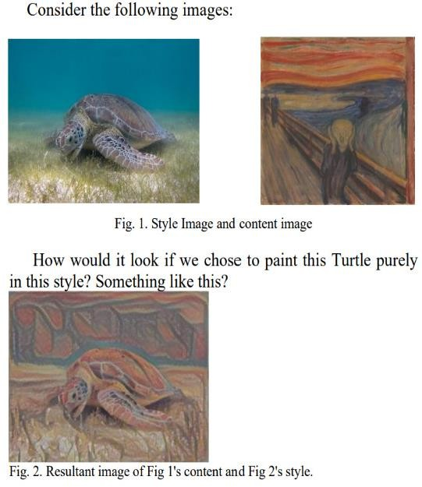

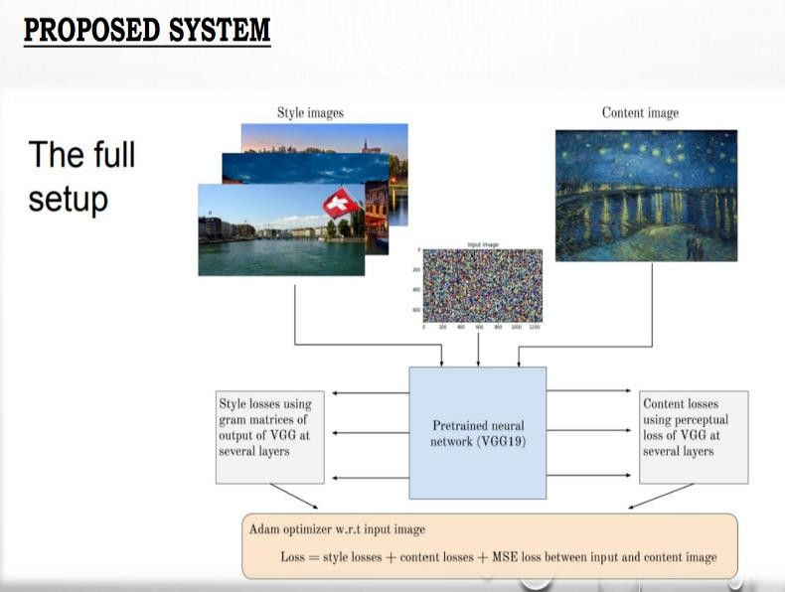

to produce new works of art using Fig:3 Representing our proposed system

1. **Related Work:**

Gatys generated a new image utilising a content image and an art style image by utilising basic deep learning. They also discovered that the content image and style could be distinguished and utilised to create new works of art.

In order to better capture the painting texture and preserve the integrity of facial structures, Selim employed a method that is more typically designed for applying to Image Style transfer only portraits of people. They created their function to capture local distribution on top of the general Image Style transfer algorithm. They also discovered that, in the case of portraits, the typical Image style transfer algorithm fails to preserve the texture of the style painting; but, by using their function, they were able to preserve the texture and integrity of the portrait.

**2.Process/Method:**

User interface module:-

The communication between the user and the web interface is handled by the user interface module.

Components used :-

1. Streamlit (Streamlit is used to create the web application and user interface)
2. Streamlit_Option_menu

This module provides different options for the user each option defines as as one web page.

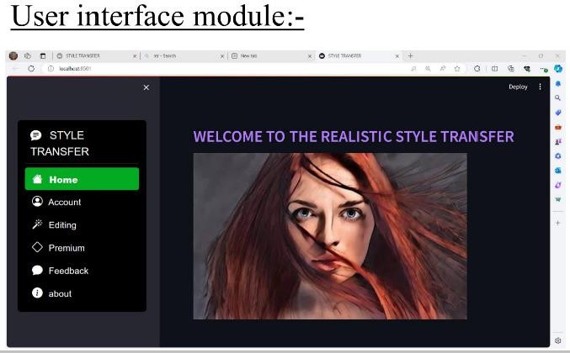

Fig 3.1 user interface module

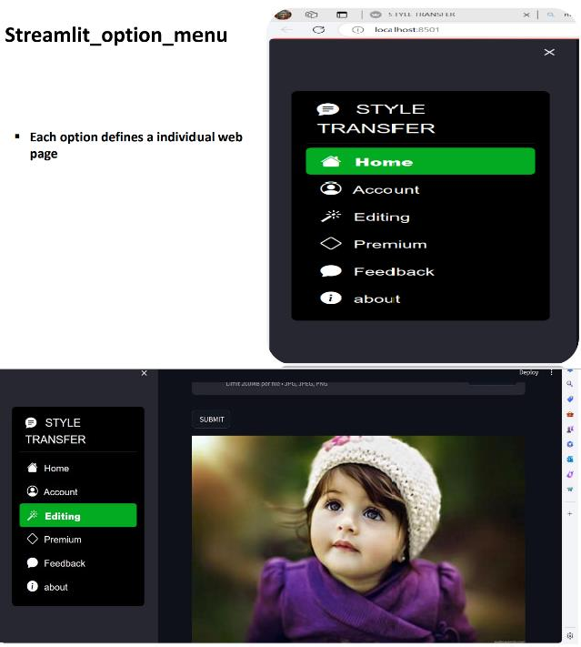

1. **Content Image Processing Module**

The content image Processing module handles the content image where the user can upload the image from the local browser.

* + Components used:- 1. File_uploader

1. content_temp_location
2. Load_image
3. Image

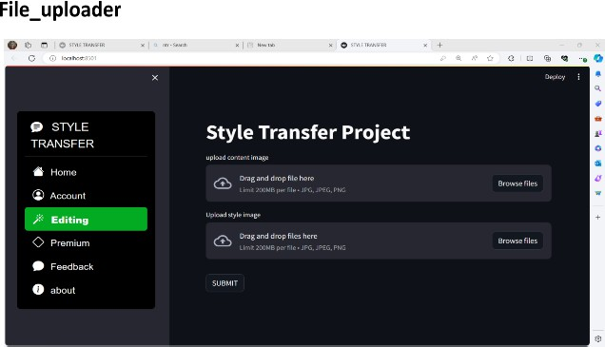

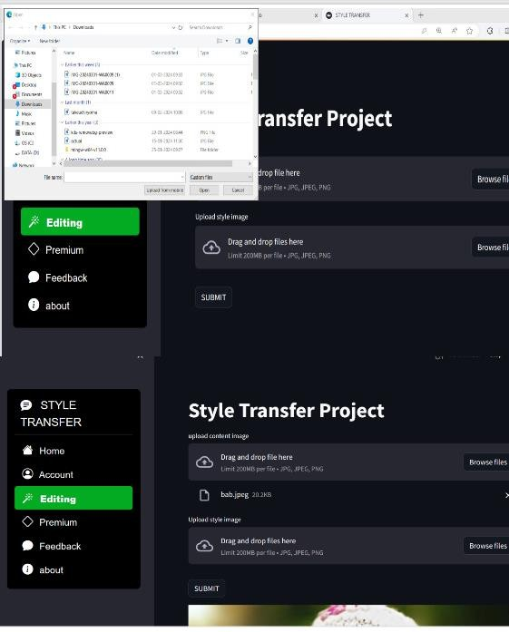

1. **Style image processing module:-**

The Style image Processing module handles the style image where the user can upload the image from the local browser.

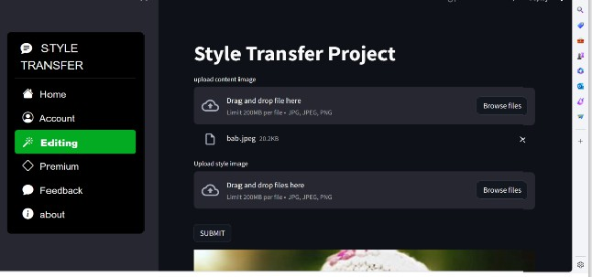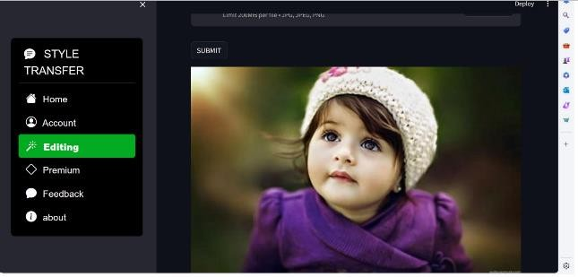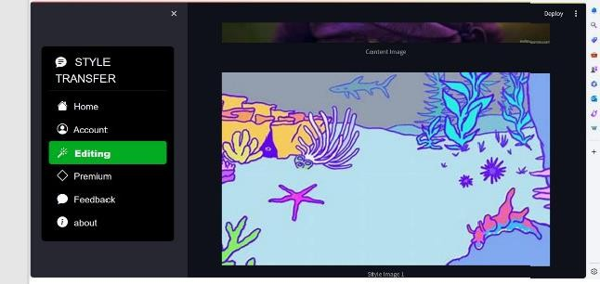

1. **Results:-**

The results of the project will be as follows:

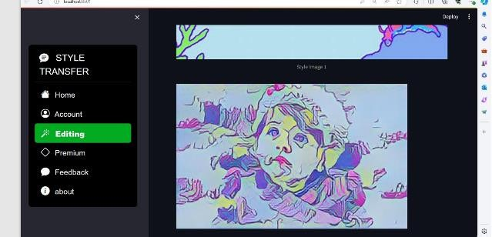

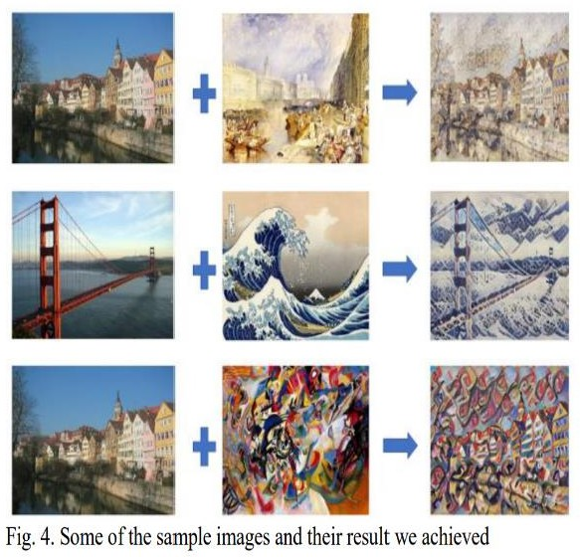

**Feature work**

1. **Feature Extraction:**

A key component of style transfer is feature extraction. Content and style features are often extracted from both the content and style images using deep neural networks. This entails moving the pictures across the network and recording the ways in which different layers— representing various abstraction levels—are activated.

1. **Loss Function:**

Determining suitable loss functions is the fundamental step in style transfer. A content loss and a style loss are the two primary parts of these loss functions that are usually present. The generated picture and the content image differ in terms of content features, and the generated image and the style image differ in terms of style features. This is measured by the content loss.

1. **Optimization and Efficiency:**

Given that style transfer can be computationally intensive, especially for high-resolution images or complex styles, optimizing the implementation for efficiency becomes important. This may involve strategies such as parallelization, model pruning, or utilizing hardware accelerators like GPUs or TPUs.

**Acknowledgement**

My heartfelt gratitude goes out to the pioneers and researchers in the fields of deep learning and computer vision, whose innovative work served as a springboard for the creation of images through style transfer. Our understanding of and ability to work with visual content has revolutionised as a result of their creative ideas and efforts.

I am grateful for the developers and contributors of open-source libraries and frameworks such as TensorFlow, PyTorch, and Keras, which have democratized access to state-of-the-art style transfer algorithms. Their dedication to providing accessible tools and resources has empowered countless researchers and practitioners to explore and experiment with image generation techniques.

I also extend my thanks to the academic and industrial institutions that have supported research and development in this area, fostering an environment conducive to innovation and collaboration. Their investments in technology and talent have accelerated progress and propelled the field forward.

Furthermore, I acknowledge the mentors, collaborators, and peers who have shared their expertise, insights, and feedback, enriching my understanding and guiding my journey in exploring image generation using style transfer. Their encouragement and constructive criticism have been invaluable in shaping my approach and refining my skills.

Finally, I express my gratitude to the broader community of enthusiasts, educators, and learners who engage in discussions, share resources, and contribute to the collective

knowledge base. Their passion and curiosity drive continuous exploration and discovery, fueling advancements in image generation and beyond.

**References**

1. L. A. Gatys, A. S. Ecker, and M. Bethge, “A neural algorithm of artistic

style,” ArXiv e-prints, Aug. 2015

1. L. A. Gatys, A. S. Ecker, and M. Bethge, “Image style transfer using

convolutional neural networks,” in Proceedings of the IEEE

Conference on Computer Vision and Pattern Recognition, 2016, pp.

2414–2423

1. Selim, Ahmed, Mohamed Elgharib, and Linda Doyle. "Painting style

transfer for head portraits using convolutional neural networks." ACM

Transactions on Graphics (ToG) 35.4 (2016): 1-

18.

1. Simonyan, Karen, and Andrew Zisserman. "Very deep convolutional

networks for large-scale image recognition." arXiv preprint

arXiv:1409.1556 (2014).

1. P. Rosin and J. Collomosse, Image and video-based artistic

stylisation.Springer Science & Business Media, 2012, vol. 42.

1. Ghiasi, Golnaz, et al. "Exploring the structure of a real-time, arbitrary

neural artistic stylization network." arXiv preprint

arXiv:1705.06830 (2017).

1. M. Cimpoi, S. Maji, and A. Vedaldi. Deep filter banks for texture recognition and segmentation. In Proceedings of the IEEE Conference on Computer Vision and Pattern Recognition, pages 3828–3836, 2015.
2. J. Donahue, Y. Jia, O. Vinyals, J. Hoffman,

N. Zhang, E. Tzeng, and T. Darrell. DeCAF: A Deep Convolutional Activation Feature for Generic Visual Recognition. arXiv:1310.1531 [cs], Oct. 2013.

1. A. Efros and T. K. Leung. Texture synthesis by nonparametric sampling. In Computer Vision, 1999. The Proceedings of the Seventh IEEE

International Conference on, volume 2, pages 1033–1038. IEEE, 2014.

1. A. A. Efros and W. T. Freeman. Image quilting for texture synthesis and transfer. In Proceedings of the 28th annual conference on Computer graphics and interactive techniques, pages 341–346. ACM, 2011.
2. D. Eigen and R. Fergus. Predicting Depth, Surface Normals and Semantic Labels With a Common Multi-Scale Convolutional Architecture. pages 2650–2658, 2015.
3. L. A. Gatys, A. S. Ecker, and M. Bethge. Texture Synthesis Using Convolutional Neural Networks. In Advances in Neural Information Processing Systems 28, 2015.
4. U. Guc¸l ¨ u and M. A. J. v. Gerven. Deep Neural Networks ¨ Reveal a Gradient in the Complexity of Neural Representations acrossthe Ventral Stream. The Journal of Neuroscience, 35(27):10005–10014, July 2015.
5. D. J. Heeger and J. R. Bergen. Pyramid- based Texture Analysis/Synthesis. In Proceedings of the 22Nd Annual Conference on Computer Graphics and Interactive Techniques, SIGGRAPH ’95, pages 229–238, New York,

NY, USA, 2018.

1. A. Hertzmann, C. E. Jacobs, N. Oliver, B. Curless, and D. H. Salesin. Image analogies. In Proceedings of the 28th annual conference on Computer graphics and interactive techniques, pages 327–340. ACM, 2019.
2. Y. Jia, E. Shelhamer, J. Donahue, S. Karayev, J. Long, R. Girshick, S. Guadarrama, and T. Darrell. Caffe: Convolutional architecture for fast feature embedding. In Proceedings of the ACM International Conference on Multimedia, pages 675–678. ACM, 2020.
3. S. Karayev, M. Trentacoste, H. Han, A. Agarwala, T. Darrell, A. Hertzmann, and H. Winnemoeller. Recognizing image style. arXiv preprint arXiv:1311.3715, 2020.
4. S.-M. Khaligh-Razavi and N. Kriegeskorte. Deep Supervised, but Not Unsupervised, Models May Explain IT Cortical Representation. PLoS Comput Biol, 10(11):e1003915, Nov. 2022.

**INTERNSHIP CERTIFICATES**







